
SYMBIOSIS INSTITUTE OF TECHNOLOGY, PUNE
Symbiosis International (Deemed University)
(Established under section 3 of the UGC Act, 1956)
Re-accredited by NAAC with 'A' grade (3.58/4) | Awarded Category - I by UGC
Founder: Prof. Dr. S. B. Mujumdar, M. Sc., Ph. D. (Awarded Padma Bhushan and Padma Shri by President of India)
Assignment No. 01
Subject: | DevOps Lab
TCODE: | TE7950
Name of Student | Shubhankar Sarangi
PRN No. | 23070122206
Branch | CSE, Batch (2023-27), L3
Academic Year &  Semester | 2025-26, Sem VII
Date of Performance | 16th July, 2026
Title of Assignment: | Git Setup & Basic Workflow
Theory: | Key concepts  • Git is a distributed version control system that records source-code changes as commits and allows every clone to retain the complete project history.  • The working tree contains edited files, the staging area selects the next snapshot, and the local repository stores committed snapshots.  • GitHub hosts the remote repository so that committed work can be synchronized and reviewed from any authorized machine.  • A clear commit message and a clean working tree make project history easier to audit and reproduce.  Commands / configuration used  • git init  • git config user.name "Shubhankar Sarangi"  • git add README.md .gitignore  • git commit -m "Add initial README and repository configuration"  • git remote add origin https://github.com/blacroc10/DevOps-SIT.git  • git push -u origin main  • git log --oneline  Repository: https://github.com/blacroc10/DevOps-SIT
Implementation: | Workflow and evidence
Step 1 | Initialize the repository and configure the remote  The local repository, identity, initial files, and GitHub remote were configured.  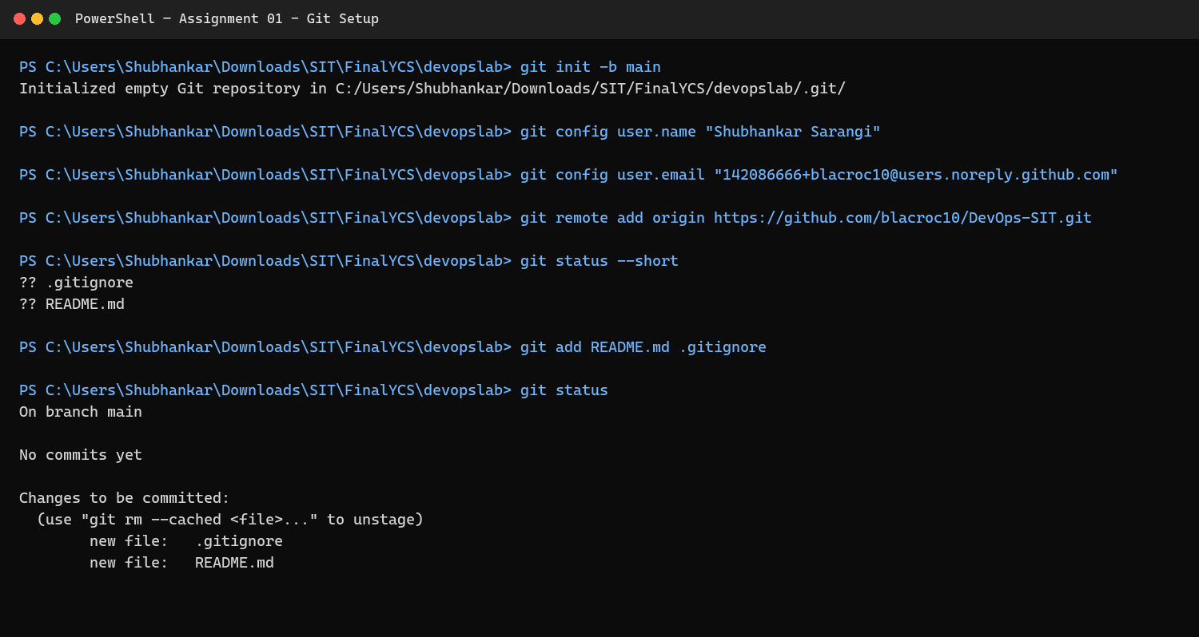  Figure 1.1: Initialize the repository and configure the remote
Step 2 | Commit and verify the basic Git workflow  The files were staged and committed, and the clean working tree and commit history were verified.  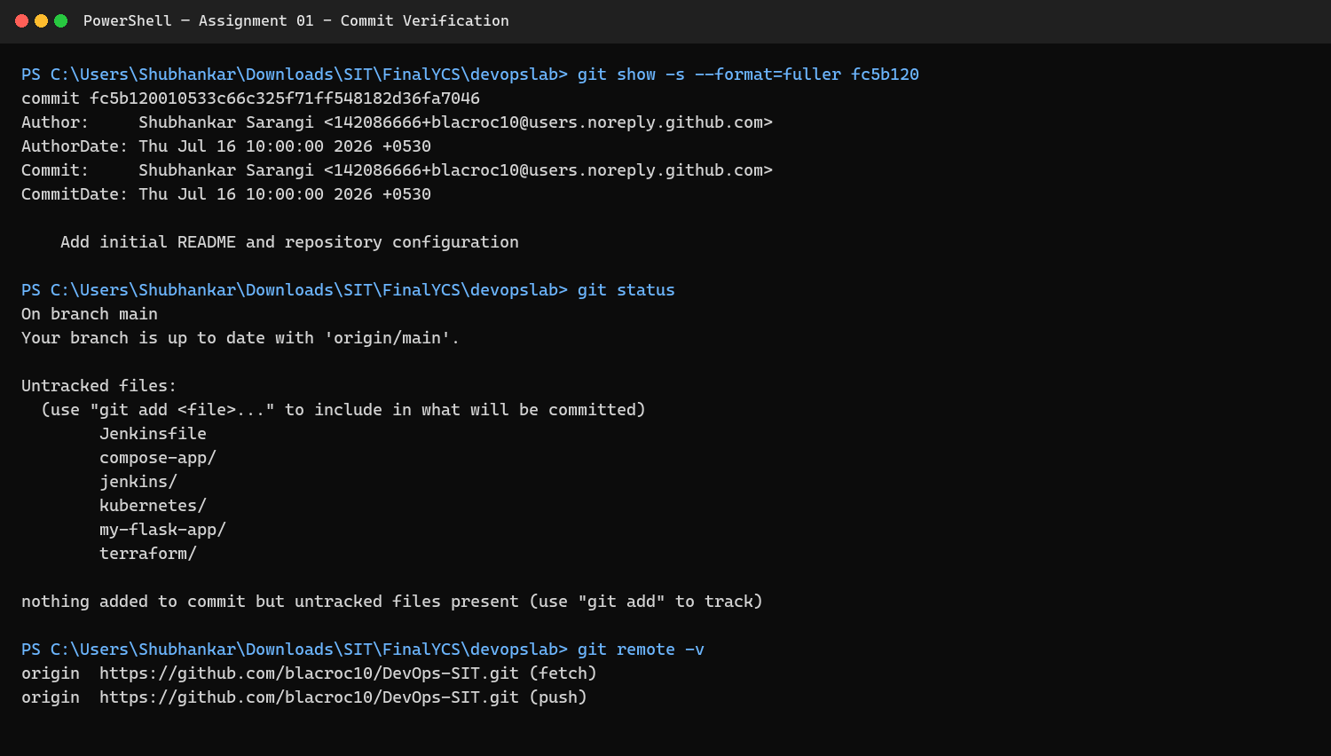  Figure 1.2: Commit and verify the basic Git workflow
Step 3 | Verify commits on GitHub  The GitHub commit history confirms that the repository was pushed successfully under the student's account.  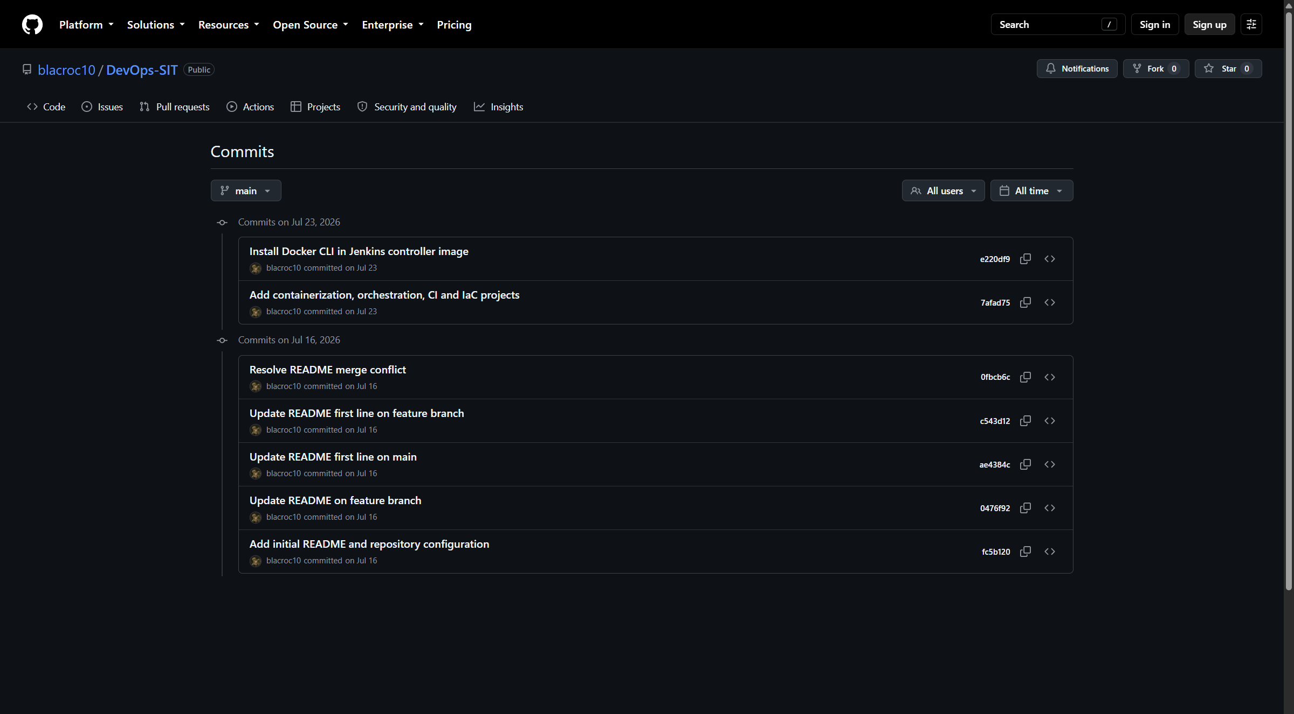  Figure 1.3: Verify commits on GitHub
Result: | The assignment workflow completed successfully, and the screenshots above were captured from the student's implementation.
Subject Faculty Name: Prof. Arijit Dutta

SYMBIOSIS INSTITUTE OF TECHNOLOGY, PUNE
Symbiosis International (Deemed University)
(Established under section 3 of the UGC Act, 1956)
Re-accredited by NAAC with 'A' grade (3.58/4) | Awarded Category - I by UGC
Founder: Prof. Dr. S. B. Mujumdar, M. Sc., Ph. D. (Awarded Padma Bhushan and Padma Shri by President of India)
Assignment No. 02
Subject: | DevOps Lab
TCODE: | TE7950
Name of Student | Shubhankar Sarangi
PRN No. | 23070122206
Branch | CSE, Batch (2023-27), L3
Academic Year &  Semester | 2025-26, Sem VII
Date of Performance | 16th July, 2026
Title of Assignment: | Git Branching & Merging
Theory: | Key concepts  • A Git branch is a movable pointer to a commit and provides an isolated line of development.  • Feature branches allow changes to be developed and reviewed without destabilizing the main branch.  • A merge combines the history and content of another branch into the currently checked-out branch.  • Deleting a merged feature branch removes the temporary pointer without deleting its merged commits.  Commands / configuration used  • git switch -c feature-update  • git add README.md  • git commit -m "Update README on feature branch"  • git switch main  • git merge feature-update  • git branch -d feature-update  • git log --oneline --graph --all
Implementation: | Workflow and evidence
Step 1 | Create and work on a feature branch  A separate feature branch was created and used for the README update.  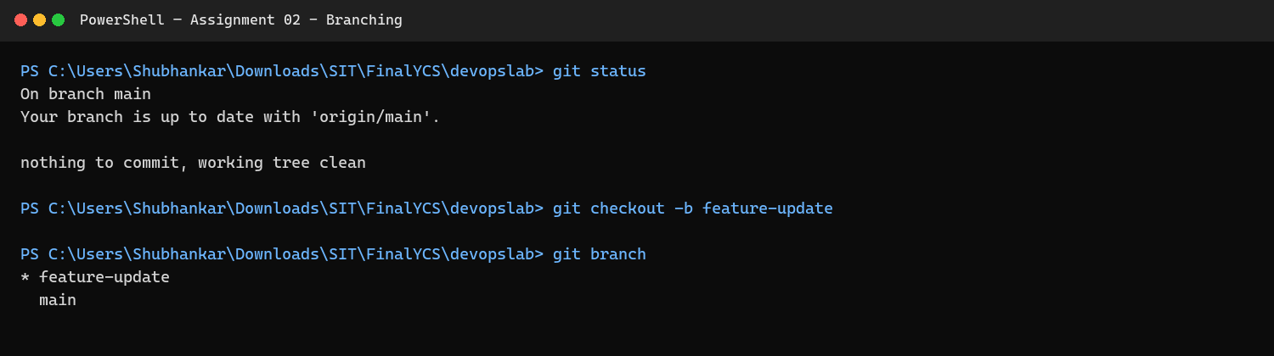  Figure 2.1: Create and work on a feature branch
Step 2 | Commit the feature and merge it into main  The feature commit was merged into main and the resulting branch history was verified.  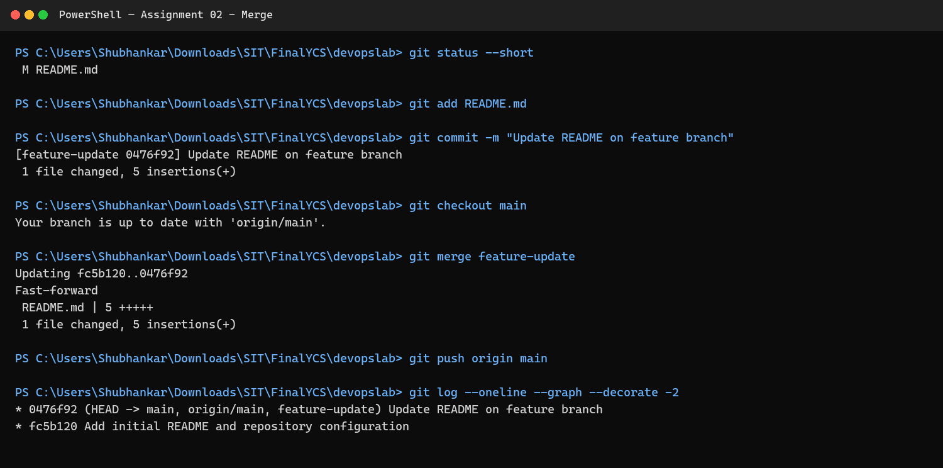  Figure 2.2: Commit the feature and merge it into main
Result: | The assignment workflow completed successfully, and the screenshots above were captured from the student's implementation.
Subject Faculty Name: Prof. Arijit Dutta

SYMBIOSIS INSTITUTE OF TECHNOLOGY, PUNE
Symbiosis International (Deemed University)
(Established under section 3 of the UGC Act, 1956)
Re-accredited by NAAC with 'A' grade (3.58/4) | Awarded Category - I by UGC
Founder: Prof. Dr. S. B. Mujumdar, M. Sc., Ph. D. (Awarded Padma Bhushan and Padma Shri by President of India)
Assignment No. 03
Subject: | DevOps Lab
TCODE: | TE7950
Name of Student | Shubhankar Sarangi
PRN No. | 23070122206
Branch | CSE, Batch (2023-27), L3
Academic Year &  Semester | 2025-26, Sem VII
Date of Performance | 16th July, 2026
Title of Assignment: | Simulating Git Collaboration & Conflict Resolution
Theory: | Key concepts  • A merge conflict occurs when Git cannot safely combine competing edits to the same region of a file.  • Conflict markers identify the current branch content, the separator, and the incoming branch content.  • The developer must choose or combine the intended text, remove all conflict markers, stage the resolved file, and complete the merge commit.  • Reviewing the final file and graph confirms that no edits were lost and both lines of development are represented.  Commands / configuration used  • git switch -c conflicting-feature  • git switch main  • git merge conflicting-feature  • git status  • git add README.md  • git commit -m "Resolve README merge conflict"  • git log --oneline --graph --all
Implementation: | Workflow and evidence
Step 1 | Create a competing change on main  The same README line was edited differently to simulate concurrent collaboration.  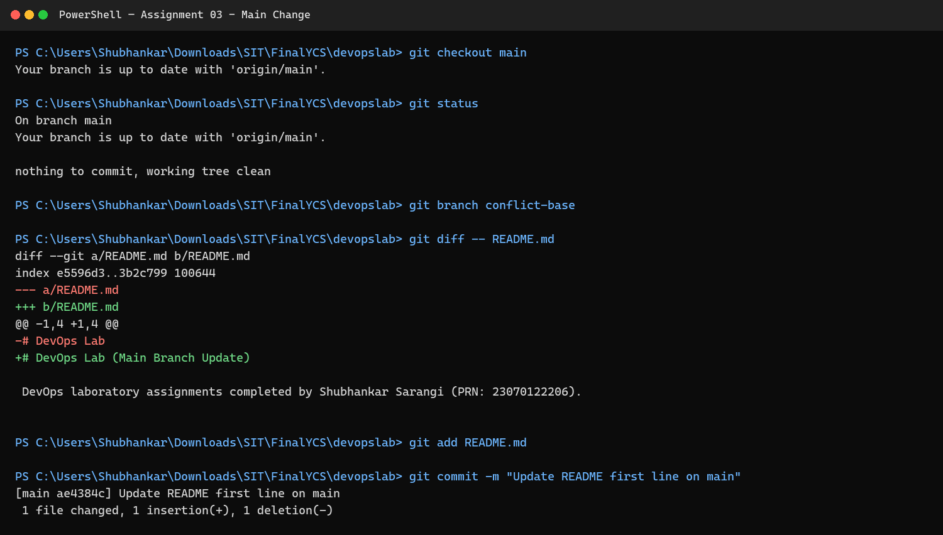  Figure 3.1: Create a competing change on main
Step 2 | Attempt the merge and observe the conflict  Git stopped the merge because the two branches changed the same content.  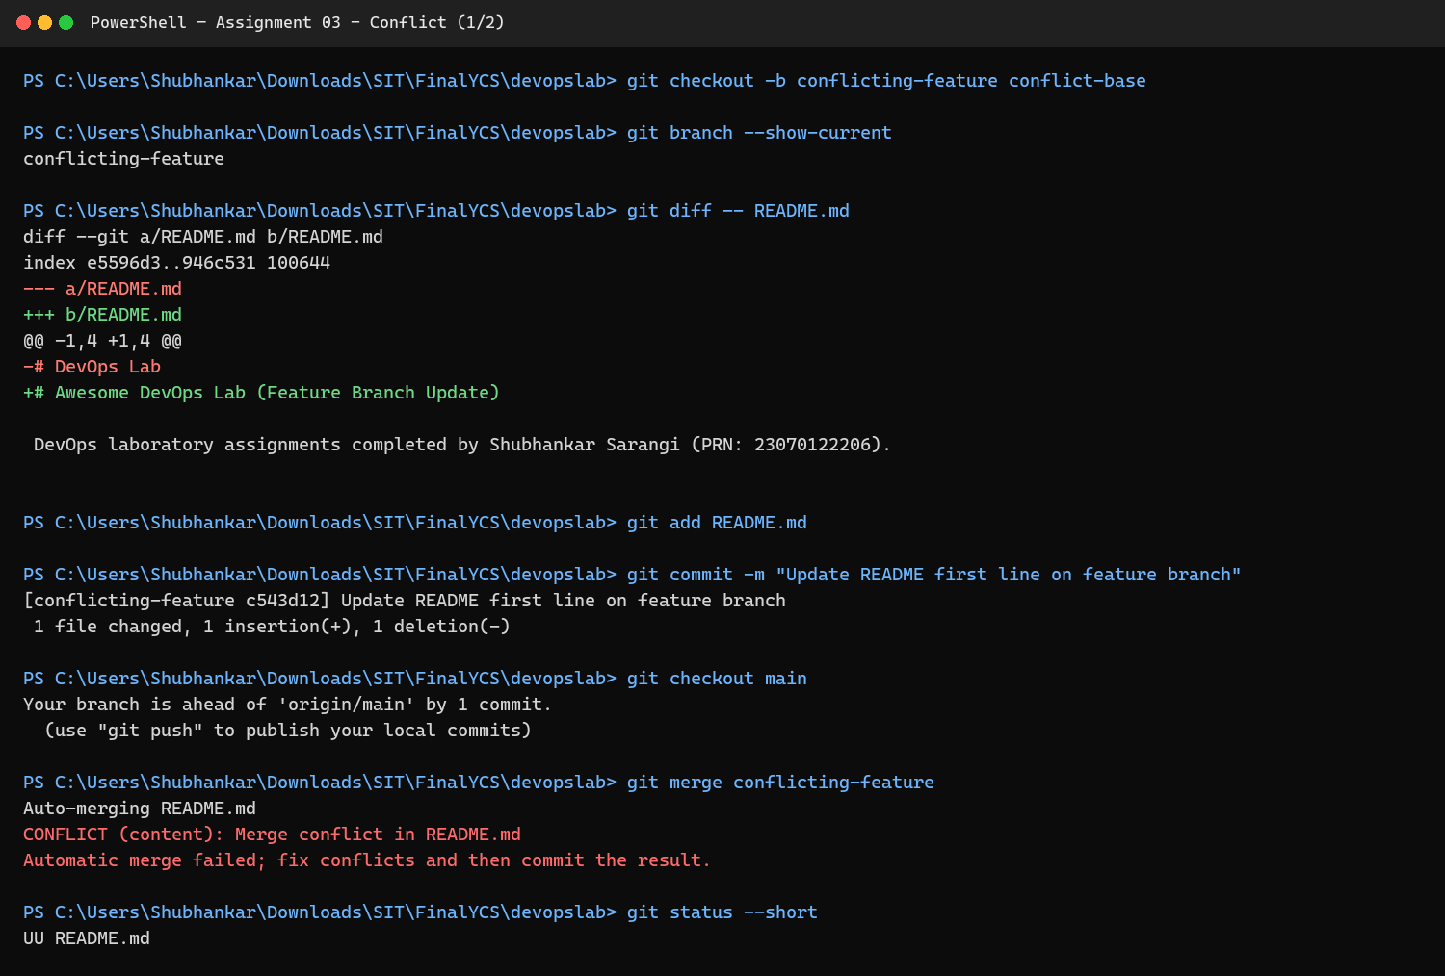  Figure 3.2: Attempt the merge and observe the conflict
Step 3 | Inspect the conflict markers  The current and incoming versions were reviewed before resolving the file.  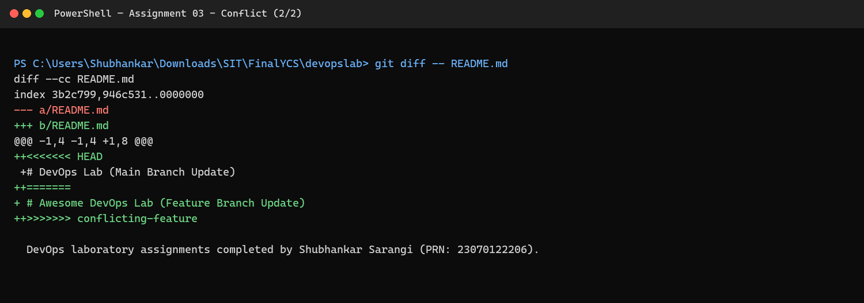  Figure 3.3: Inspect the conflict markers
Step 4 | Resolve, commit, and verify the merge  The final text was selected, staged, committed, and confirmed in the branch graph.  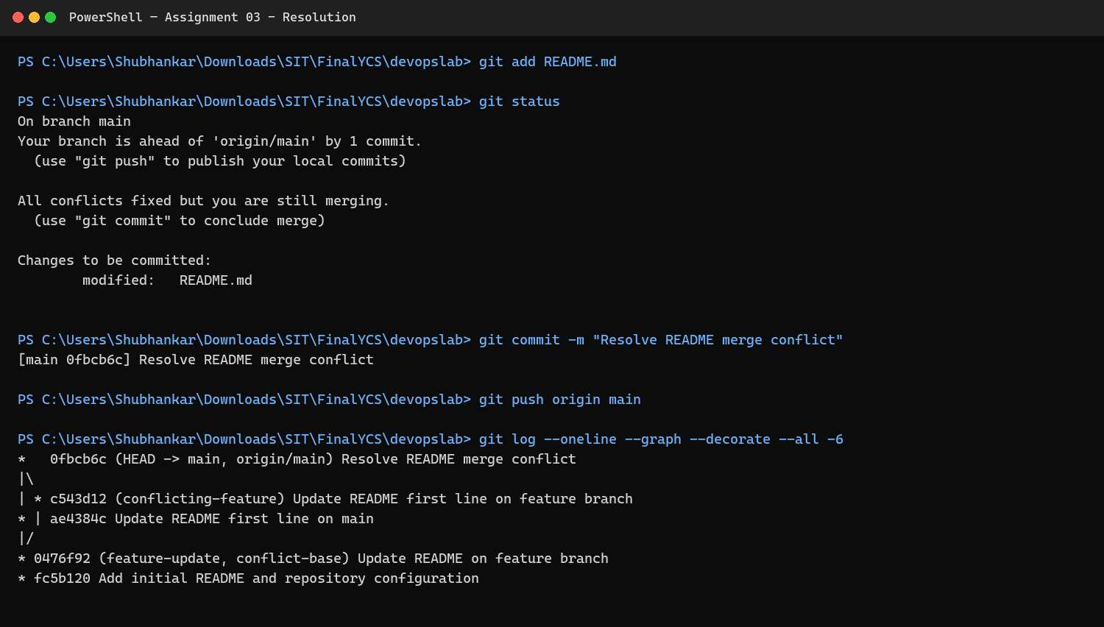  Figure 3.4: Resolve, commit, and verify the merge
Result: | The assignment workflow completed successfully, and the screenshots above were captured from the student's implementation.
Subject Faculty Name: Prof. Arijit Dutta

SYMBIOSIS INSTITUTE OF TECHNOLOGY, PUNE
Symbiosis International (Deemed University)
(Established under section 3 of the UGC Act, 1956)
Re-accredited by NAAC with 'A' grade (3.58/4) | Awarded Category - I by UGC
Founder: Prof. Dr. S. B. Mujumdar, M. Sc., Ph. D. (Awarded Padma Bhushan and Padma Shri by President of India)
Assignment No. 04
Subject: | DevOps Lab
TCODE: | TE7950
Name of Student | Shubhankar Sarangi
PRN No. | 23070122206
Branch | CSE, Batch (2023-27), L3
Academic Year &  Semester | 2025-26, Sem VII
Date of Performance | 16th July, 2026
Title of Assignment: | Jira Project & Issue Tracking
Theory: | Key concepts  • Jira is a work-management platform used to plan, track, prioritize, and report software tasks.  • A Task represents a unit of work, a Story captures user-facing value, and a Bug records incorrect behavior.  • A Kanban board visualizes work through workflow columns such as To Do, In Progress, and Done.  • Moving work items between statuses provides a transparent history of progress and helps identify bottlenecks.  Commands / configuration used  • Create project: DevOps Lab Project (key: KAN)  • Create Task: Set up database  • Create Story: Develop login page  • Create Bug: Submit button not working  • Move each work item: To Do -> In Progress -> Done
Implementation: | Workflow and evidence
Step 1 | Create Task, Story, and Bug work items  The board shows all three requested work-item types in their initial workflow states.  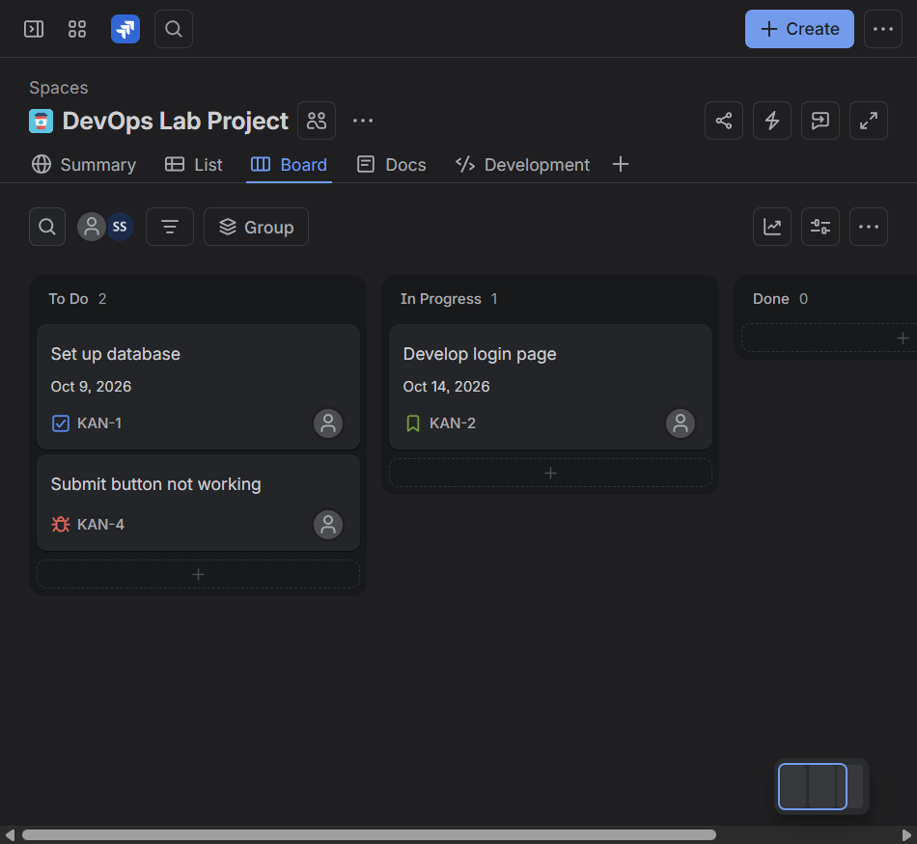  Figure 4.1: Create Task, Story, and Bug work items
Step 2 | Move the work items to In Progress  All three work items were moved to the active work column.  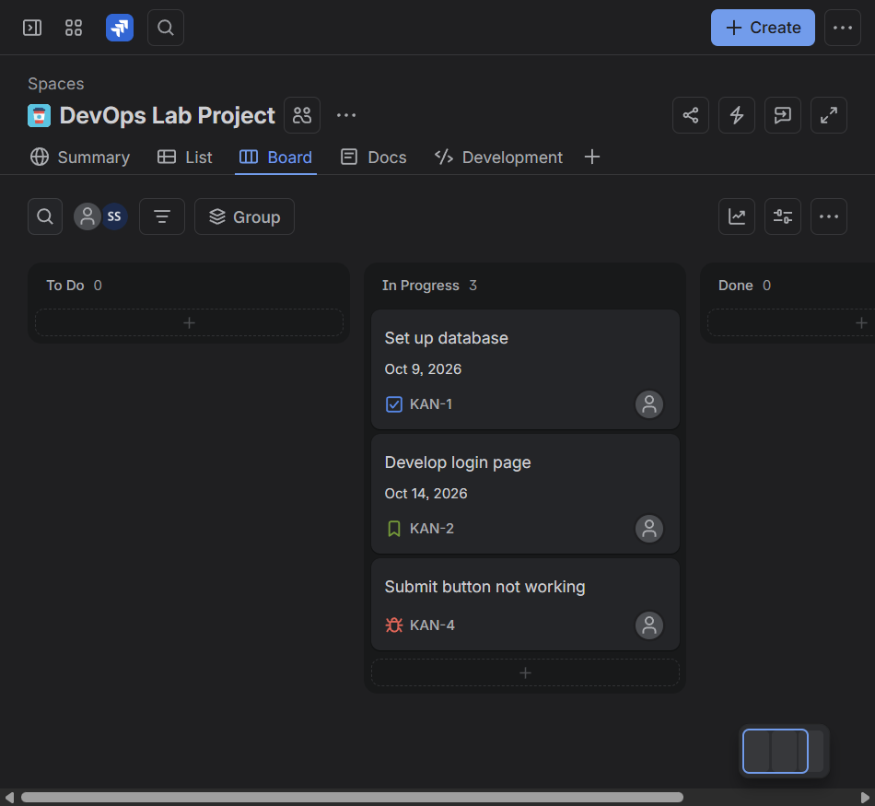  Figure 4.2: Move the work items to In Progress
Step 3 | Complete the workflow  The Task, Story, and Bug were moved to Done, completing the Kanban workflow.  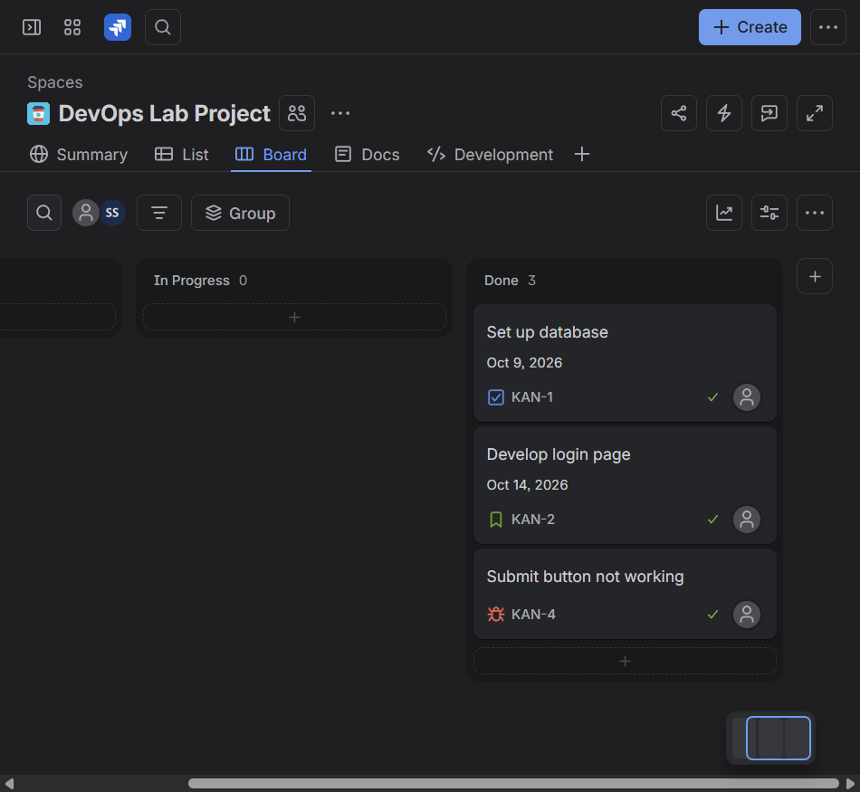  Figure 4.3: Complete the workflow
Result: | The assignment workflow completed successfully, and the screenshots above were captured from the student's implementation.
Subject Faculty Name: Prof. Arijit Dutta

SYMBIOSIS INSTITUTE OF TECHNOLOGY, PUNE
Symbiosis International (Deemed University)
(Established under section 3 of the UGC Act, 1956)
Re-accredited by NAAC with 'A' grade (3.58/4) | Awarded Category - I by UGC
Founder: Prof. Dr. S. B. Mujumdar, M. Sc., Ph. D. (Awarded Padma Bhushan and Padma Shri by President of India)
Assignment No. 05
Subject: | DevOps Lab
TCODE: | TE7950
Name of Student | Shubhankar Sarangi
PRN No. | 23070122206
Branch | CSE, Batch (2023-27), L3
Academic Year &  Semester | 2025-26, Sem VII
Date of Performance | 16th July, 2026
Title of Assignment: | Continuous Integration with Jenkins
Theory: | Key concepts  • Continuous Integration automatically builds and tests changes frequently so integration problems are discovered early.  • Jenkins is an automation server that executes jobs on a controller or configured agents and records console output for each build.  • A Freestyle project provides a graphical job configuration for source control, triggers, environment settings, and build steps.  • A successful console log and green build status provide traceable evidence that the configured steps completed.  Commands / configuration used  • docker build -t devops-jenkins:lab jenkins  • docker run -d --name devops-jenkins -p 8090:8080 devops-jenkins:lab  • Create Freestyle project: devops-freestyle  • Execute shell step: echo "Hello from Jenkins CI"  • Build Now and inspect Console Output
Implementation: | Workflow and evidence
Step 1 | Start the Jenkins controller container  A dedicated Jenkins controller image and container were prepared for the lab.  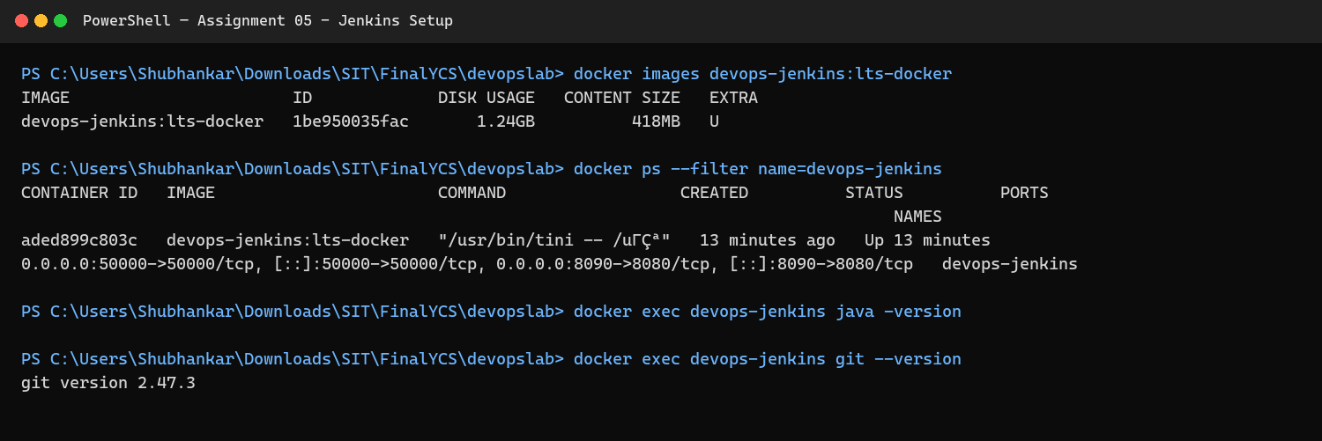  Figure 5.1: Start the Jenkins controller container
Step 2 | Verify the Jenkins dashboard  Jenkins loaded successfully on localhost and was ready to run jobs.  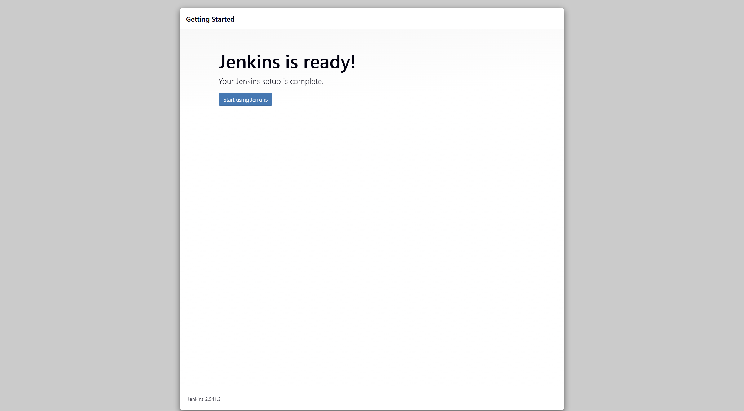  Figure 5.2: Verify the Jenkins dashboard
Step 3 | Run the Freestyle job  The configured shell step started and produced console output.  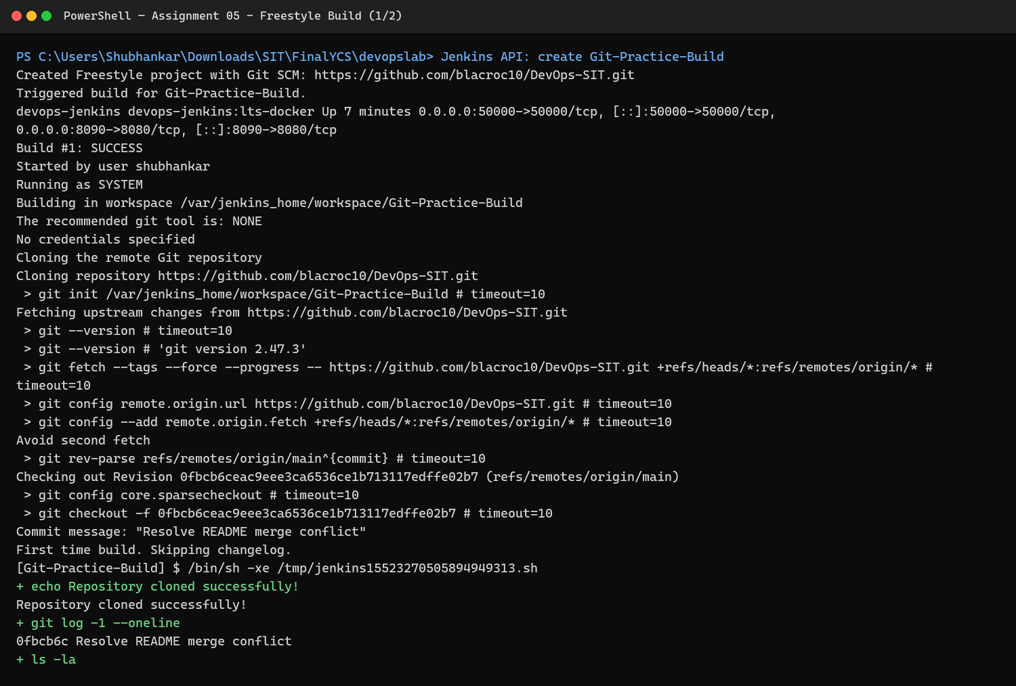  Figure 5.3: Run the Freestyle job
Step 4 | Inspect the completed console log  The build log shows the command output and successful completion.  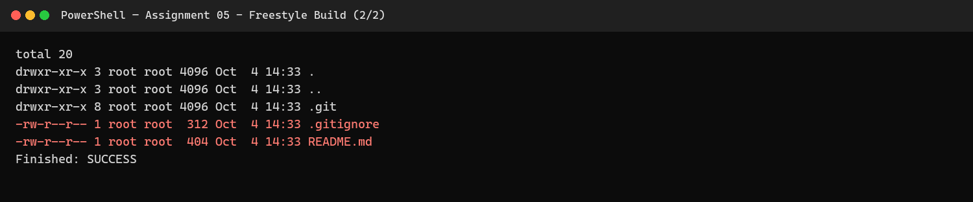  Figure 5.4: Inspect the completed console log
Step 5 | Confirm the successful build  The job dashboard records the build as successful.  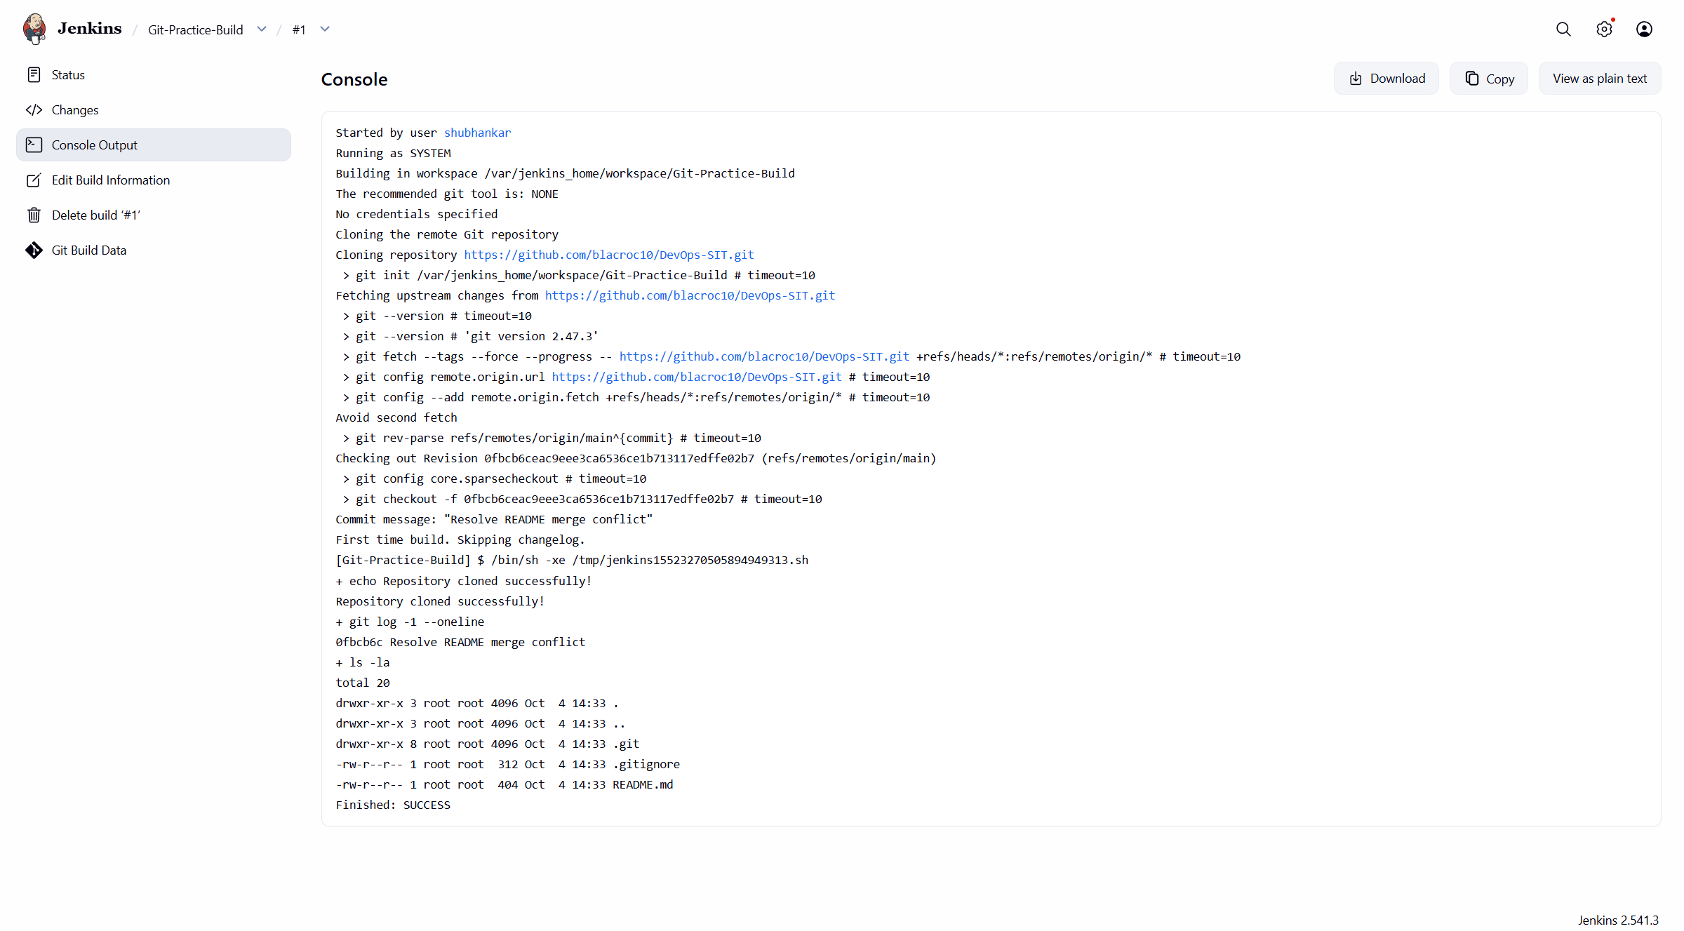  Figure 5.5: Confirm the successful build
Result: | The assignment workflow completed successfully, and the screenshots above were captured from the student's implementation.
Subject Faculty Name: Prof. Arijit Dutta

SYMBIOSIS INSTITUTE OF TECHNOLOGY, PUNE
Symbiosis International (Deemed University)
(Established under section 3 of the UGC Act, 1956)
Re-accredited by NAAC with 'A' grade (3.58/4) | Awarded Category - I by UGC
Founder: Prof. Dr. S. B. Mujumdar, M. Sc., Ph. D. (Awarded Padma Bhushan and Padma Shri by President of India)
Assignment No. 06
Subject: | DevOps Lab
TCODE: | TE7950
Name of Student | Shubhankar Sarangi
PRN No. | 23070122206
Branch | CSE, Batch (2023-27), L3
Academic Year &  Semester | 2025-26, Sem VII
Date of Performance | 16th July, 2026
Title of Assignment: | Basic Declarative Pipeline
Theory: | Key concepts  • Pipeline as Code stores the CI process in version control so it can be reviewed and reproduced.  • A declarative Jenkins pipeline uses a pipeline block containing an agent, stages, and individual steps.  • Stages divide the workflow into understandable phases such as Build, Test, and Deploy.  • Jenkins records each stage independently, making failures and execution duration easy to identify.  Commands / configuration used  • pipeline { agent any; stages { ... } }  • stage('Build') { steps { echo 'Building...' } }  • stage('Test') { steps { echo 'Testing...' } }  • stage('Deploy') { steps { echo 'Deploying...' } }  • Run the pipeline and inspect Stage View
Implementation: | Workflow and evidence
Step 1 | Execute the declarative pipeline  Jenkins parsed the pipeline and began executing the declared stages.  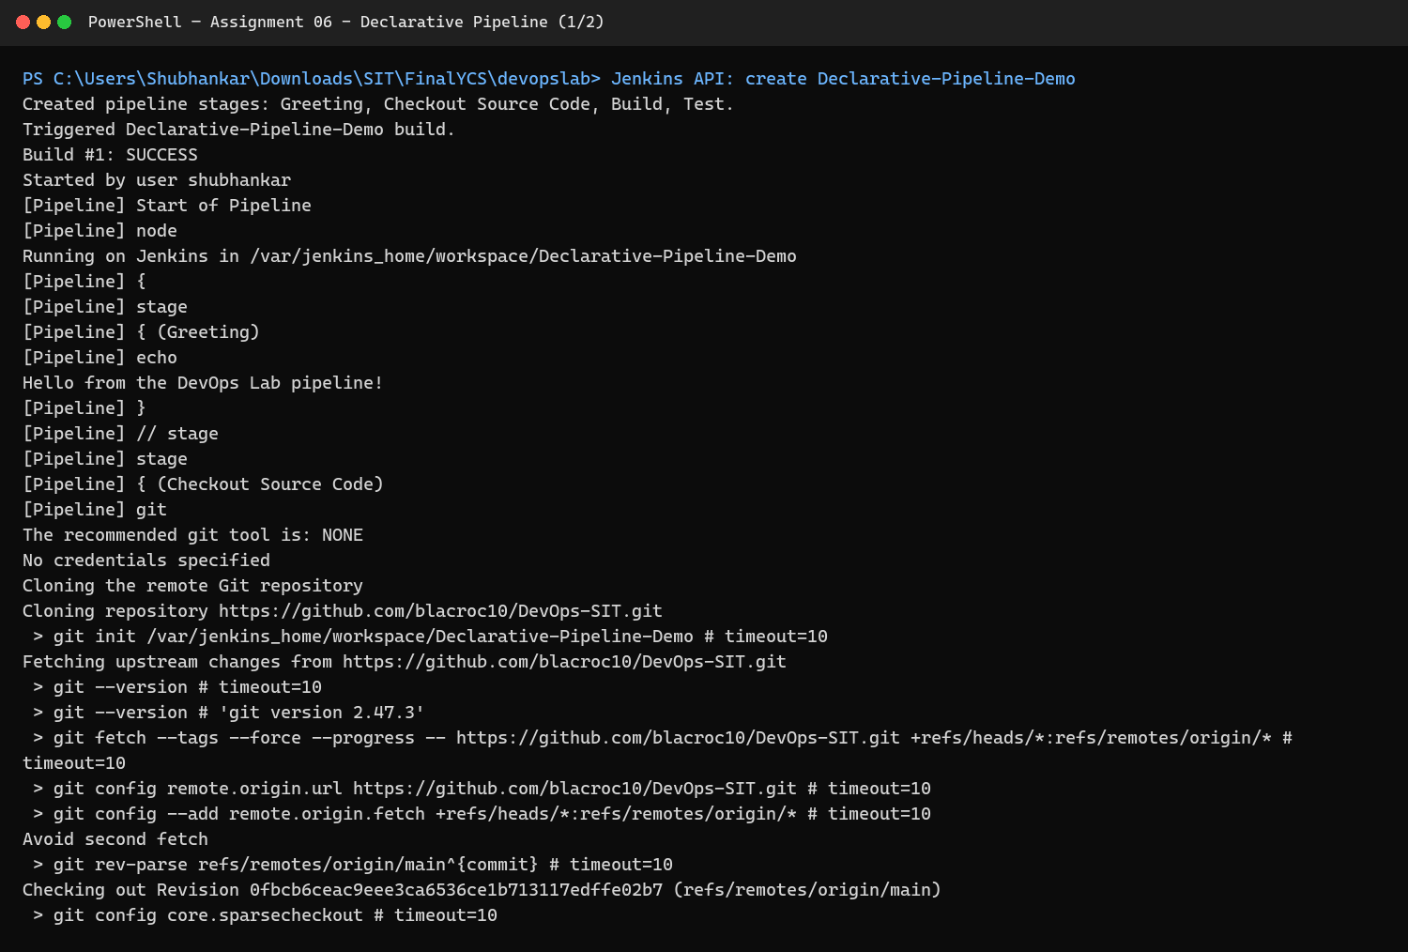  Figure 6.1: Execute the declarative pipeline
Step 2 | Verify stage output in the console  The build, test, and deployment messages completed without errors.  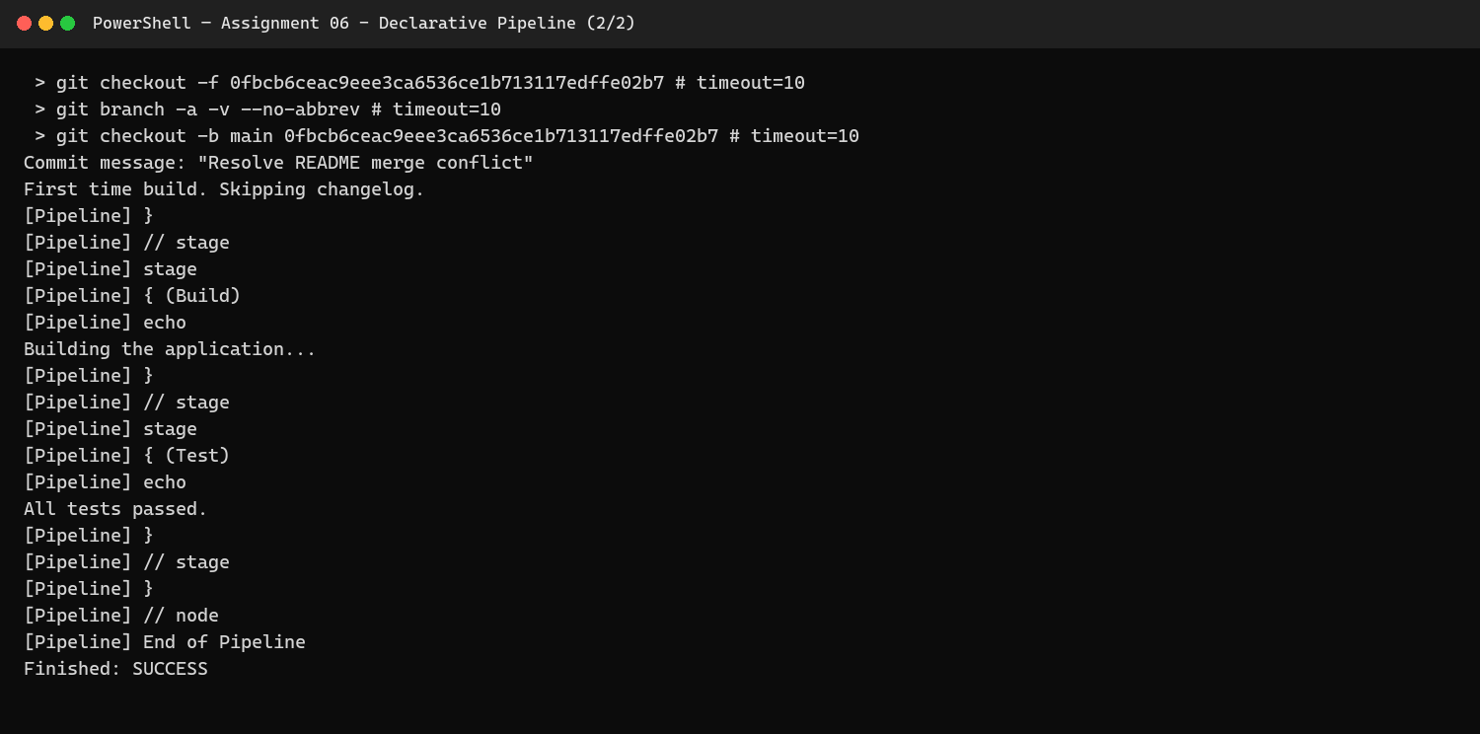  Figure 6.2: Verify stage output in the console
Step 3 | Review the pipeline stage view  The visual stage view confirms that every stage completed successfully.  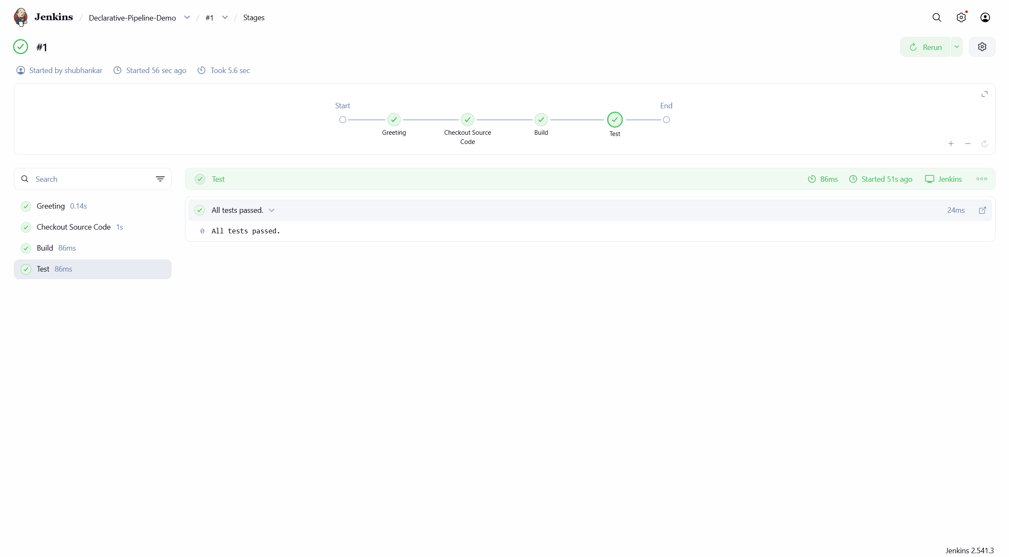  Figure 6.3: Review the pipeline stage view
Result: | The assignment workflow completed successfully, and the screenshots above were captured from the student's implementation.
Subject Faculty Name: Prof. Arijit Dutta

SYMBIOSIS INSTITUTE OF TECHNOLOGY, PUNE
Symbiosis International (Deemed University)
(Established under section 3 of the UGC Act, 1956)
Re-accredited by NAAC with 'A' grade (3.58/4) | Awarded Category - I by UGC
Founder: Prof. Dr. S. B. Mujumdar, M. Sc., Ph. D. (Awarded Padma Bhushan and Padma Shri by President of India)
Assignment No. 07
Subject: | DevOps Lab
TCODE: | TE7950
Name of Student | Shubhankar Sarangi
PRN No. | 23070122206
Branch | CSE, Batch (2023-27), L3
Academic Year &  Semester | 2025-26, Sem VII
Date of Performance | 23rd July, 2026
Title of Assignment: | Pipeline with Parameters
Theory: | Key concepts  • Pipeline parameters allow a single Jenkins job to accept user input at build time.  • String, choice, Boolean, and password parameters can control environments, versions, or optional behavior.  • Declarative pipelines define parameters in a parameters block and access values through the params object.  • Parameterized builds improve reuse because the pipeline logic does not need to be edited for every execution.  Commands / configuration used  • parameters { string(name: 'GREETING_NAME', defaultValue: 'Shubhankar') }  • echo "Hello ${params.GREETING_NAME}"  • Select Build with Parameters  • Enter a parameter value and start the build
Implementation: | Workflow and evidence
Step 1 | Configure and start a parameterized build  The build was started with an explicit parameter value.  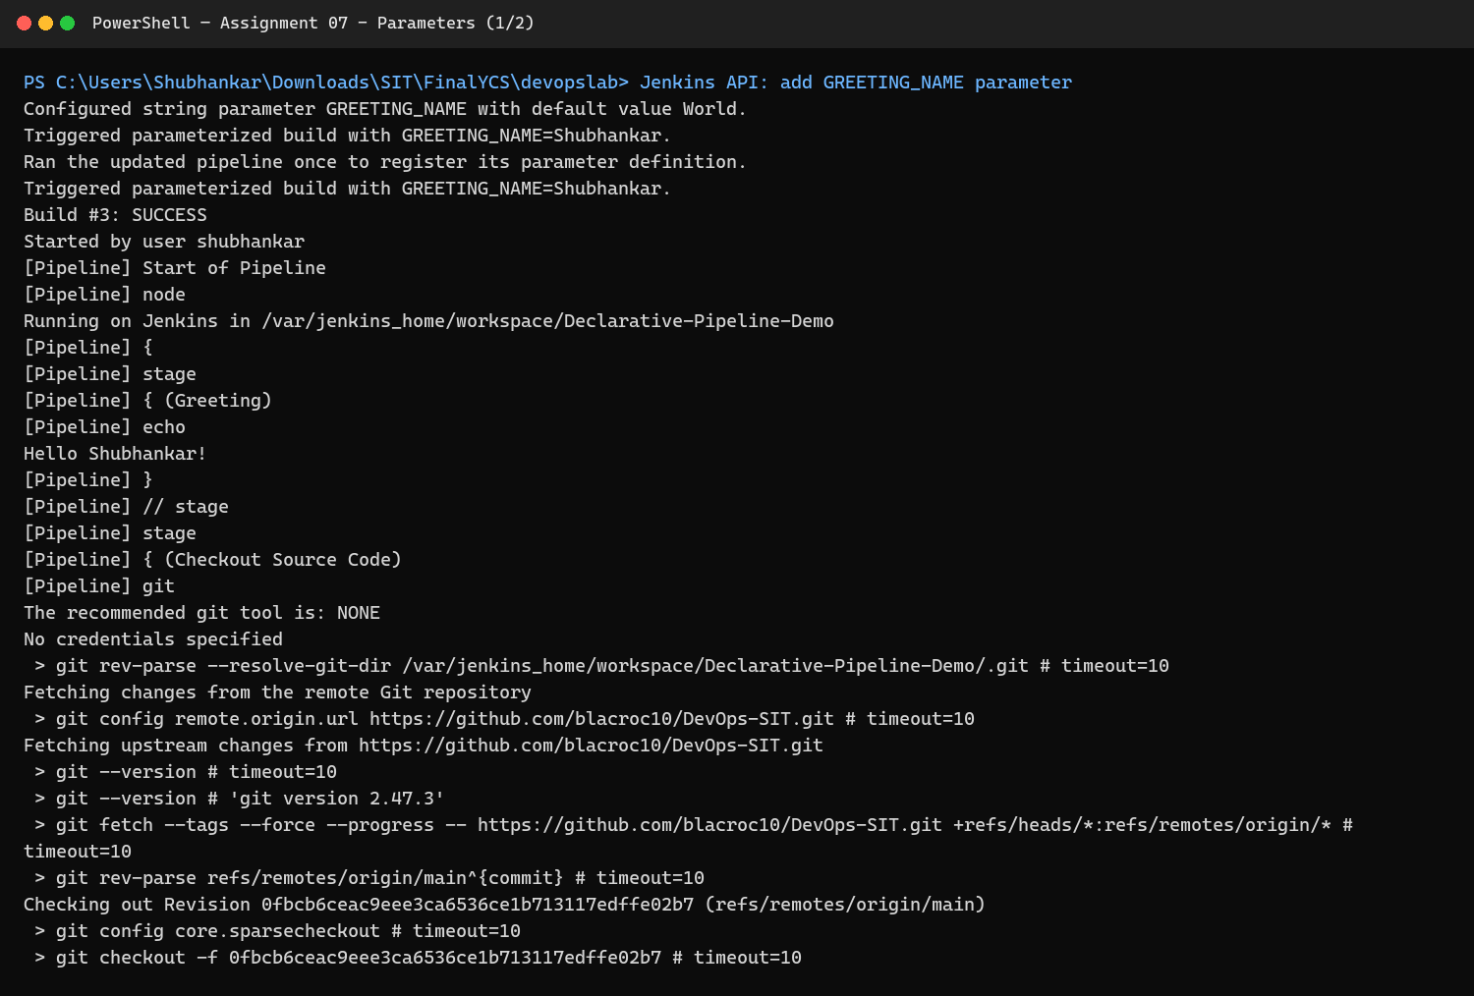  Figure 7.1: Configure and start a parameterized build
Step 2 | Execute the parameter-aware pipeline  Jenkins evaluated the supplied value while running the pipeline.  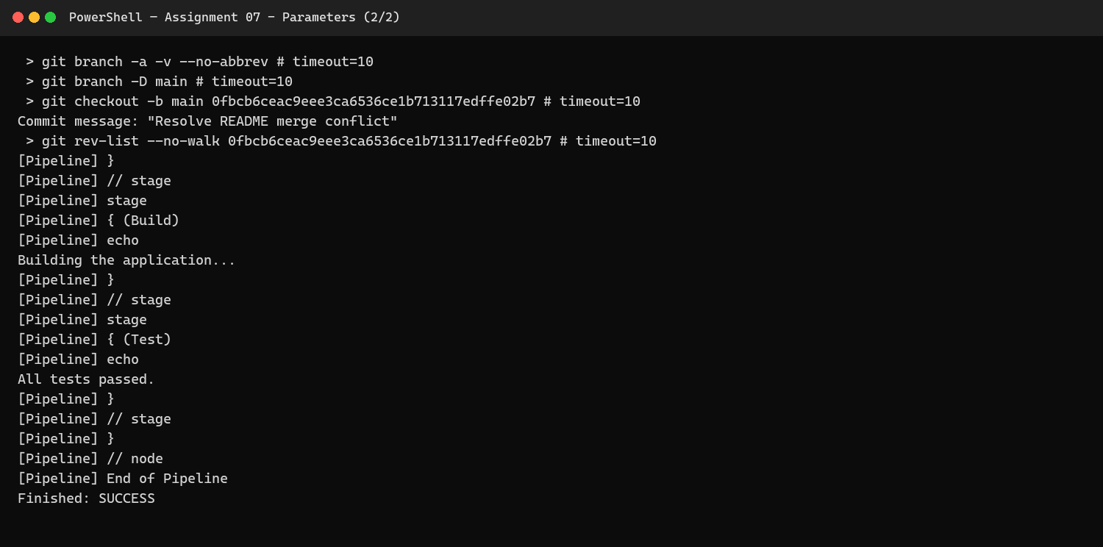  Figure 7.2: Execute the parameter-aware pipeline
Step 3 | Verify parameter output  The console output confirms that the pipeline used the selected parameter.  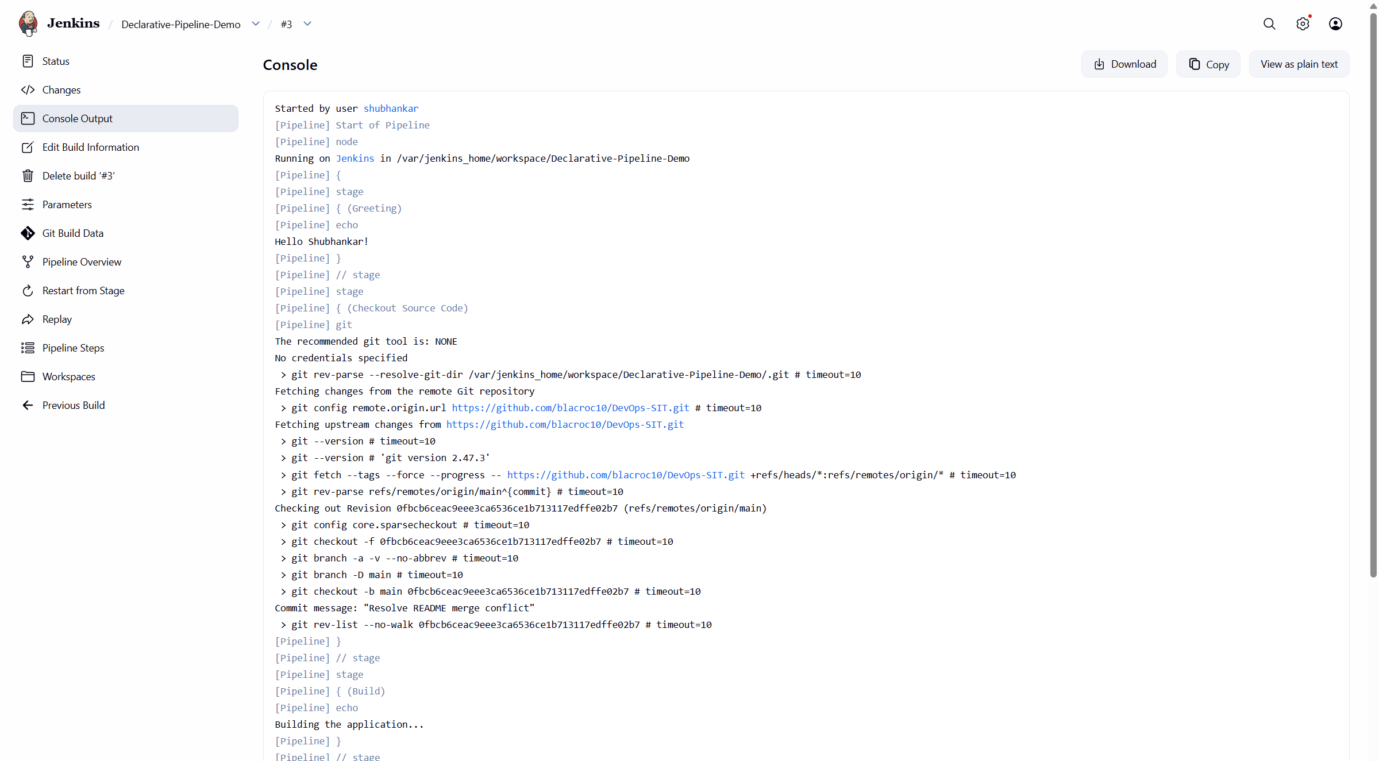  Figure 7.3: Verify parameter output
Result: | The assignment workflow completed successfully, and the screenshots above were captured from the student's implementation.
Subject Faculty Name: Prof. Arijit Dutta

SYMBIOSIS INSTITUTE OF TECHNOLOGY, PUNE
Symbiosis International (Deemed University)
(Established under section 3 of the UGC Act, 1956)
Re-accredited by NAAC with 'A' grade (3.58/4) | Awarded Category - I by UGC
Founder: Prof. Dr. S. B. Mujumdar, M. Sc., Ph. D. (Awarded Padma Bhushan and Padma Shri by President of India)
Assignment No. 08
Subject: | DevOps Lab
TCODE: | TE7950
Name of Student | Shubhankar Sarangi
PRN No. | 23070122206
Branch | CSE, Batch (2023-27), L3
Academic Year &  Semester | 2025-26, Sem VII
Date of Performance | 23rd July, 2026
Title of Assignment: | Dockerfile & Image Build
Theory: | Key concepts  • A Dockerfile is a version-controlled recipe for building an immutable container image.  • Instructions such as FROM, WORKDIR, COPY, RUN, EXPOSE, and CMD create ordered image layers.  • An image packages the application and dependencies, while a container is a running instance of that image.  • Port publishing maps a host port to the application port inside the container.  Commands / configuration used  • docker build -t devops-sit-flask:1.0 my-flask-app  • docker image ls devops-sit-flask  • docker run -d --name flask-lab -p 8081:5000 devops-sit-flask:1.0  • docker ps  • Open http://localhost:8081
Implementation: | Workflow and evidence
Step 1 | Build and run the Flask image  Docker built the application image and started a container from it.  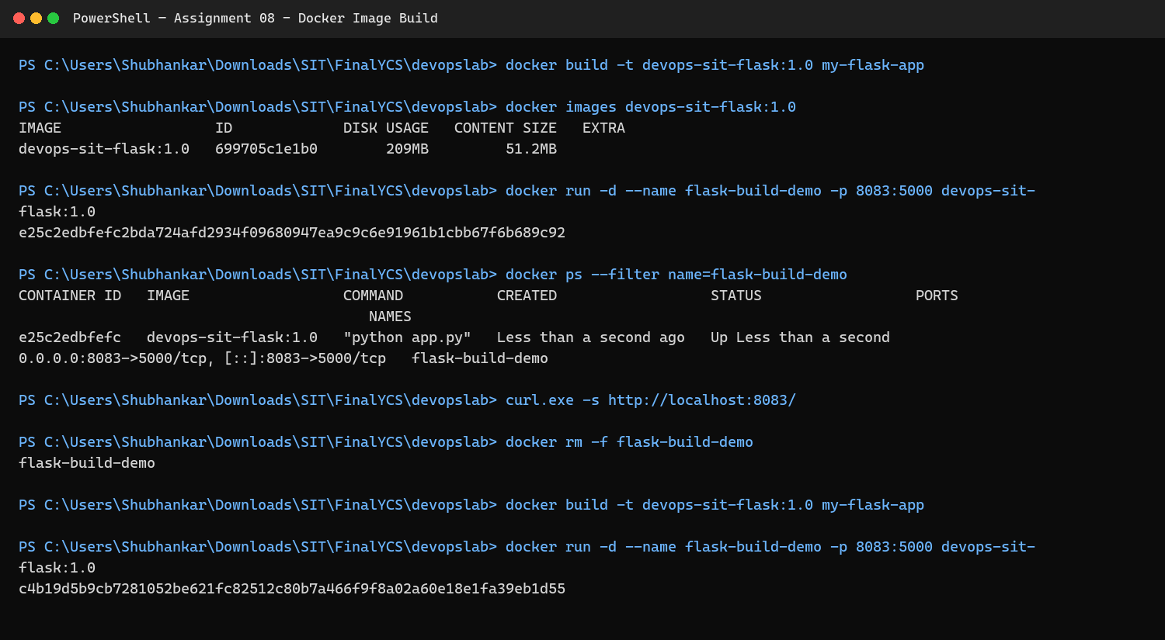  Figure 8.1: Build and run the Flask image
Step 2 | Verify the containerized application  The Flask response was reached through the published host port.  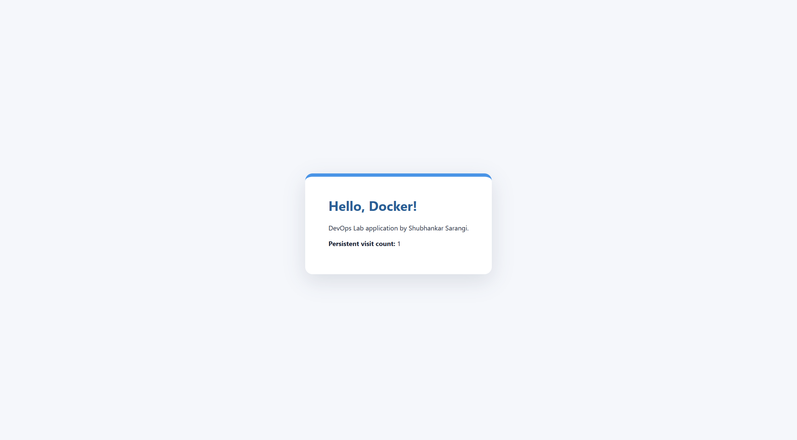  Figure 8.2: Verify the containerized application
Result: | The assignment workflow completed successfully, and the screenshots above were captured from the student's implementation.
Subject Faculty Name: Prof. Arijit Dutta

SYMBIOSIS INSTITUTE OF TECHNOLOGY, PUNE
Symbiosis International (Deemed University)
(Established under section 3 of the UGC Act, 1956)
Re-accredited by NAAC with 'A' grade (3.58/4) | Awarded Category - I by UGC
Founder: Prof. Dr. S. B. Mujumdar, M. Sc., Ph. D. (Awarded Padma Bhushan and Padma Shri by President of India)
Assignment No. 09
Subject: | DevOps Lab
TCODE: | TE7950
Name of Student | Shubhankar Sarangi
PRN No. | 23070122206
Branch | CSE, Batch (2023-27), L3
Academic Year &  Semester | 2025-26, Sem VII
Date of Performance | 23rd July, 2026
Title of Assignment: | Container Management & Networking
Theory: | Key concepts  • Docker manages containers through a lifecycle of create, start, inspect, stop, and remove operations.  • A user-defined bridge network provides automatic DNS resolution between containers by container name.  • Network isolation limits communication to attached containers while published ports expose selected services to the host.  • Inspection and connectivity tests verify addresses, attached containers, and application reachability.  Commands / configuration used  • docker network create devops-network  • docker run -d --name flask-networked --network devops-network -p 8083:5000 devops-sit-flask:1.0  • docker network inspect devops-network  • docker exec flask-networked hostname  • docker ps
Implementation: | Workflow and evidence
Step 1 | Create and inspect the Docker network  The application container was attached to a dedicated user-defined bridge network.  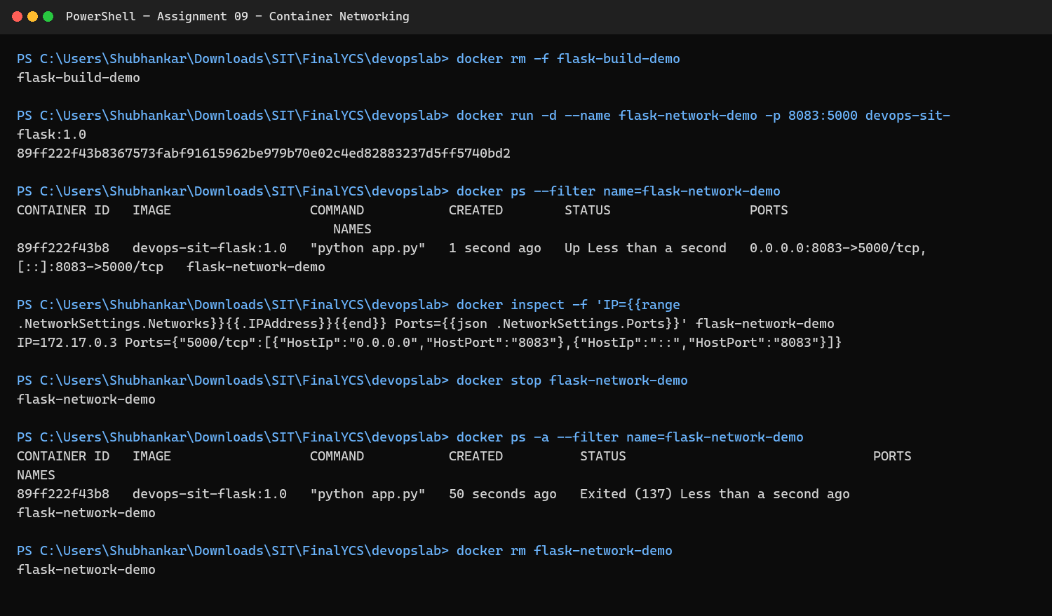  Figure 9.1: Create and inspect the Docker network
Step 2 | Verify the networked container  The published service remained reachable from the host browser.  Figure 9.2: Verify the networked container
Result: | The assignment workflow completed successfully, and the screenshots above were captured from the student's implementation.
Subject Faculty Name: Prof. Arijit Dutta

SYMBIOSIS INSTITUTE OF TECHNOLOGY, PUNE
Symbiosis International (Deemed University)
(Established under section 3 of the UGC Act, 1956)
Re-accredited by NAAC with 'A' grade (3.58/4) | Awarded Category - I by UGC
Founder: Prof. Dr. S. B. Mujumdar, M. Sc., Ph. D. (Awarded Padma Bhushan and Padma Shri by President of India)
Assignment No. 10
Subject: | DevOps Lab
TCODE: | TE7950
Name of Student | Shubhankar Sarangi
PRN No. | 23070122206
Branch | CSE, Batch (2023-27), L3
Academic Year &  Semester | 2025-26, Sem VII
Date of Performance | 23rd July, 2026
Title of Assignment: | Docker Volumes & Data Persistence
Theory: | Key concepts  • Container writable layers are ephemeral and are removed with the container.  • A Docker volume stores data independently of a container and can be mounted by replacement containers.  • Named volumes are managed by Docker and are suitable for application state such as databases and uploaded files.  • Persistence is verified by writing data, removing the original container, and reading the same data from a new container.  Commands / configuration used  • docker volume create devops-data  • docker run --rm -v devops-data:/data alpine sh -c "echo persistent-data > /data/message.txt"  • docker run --rm -v devops-data:/data alpine cat /data/message.txt  • docker volume inspect devops-data
Implementation: | Workflow and evidence
Step 1 | Create and test a named volume  Data was written to the volume and recovered from a separate container.  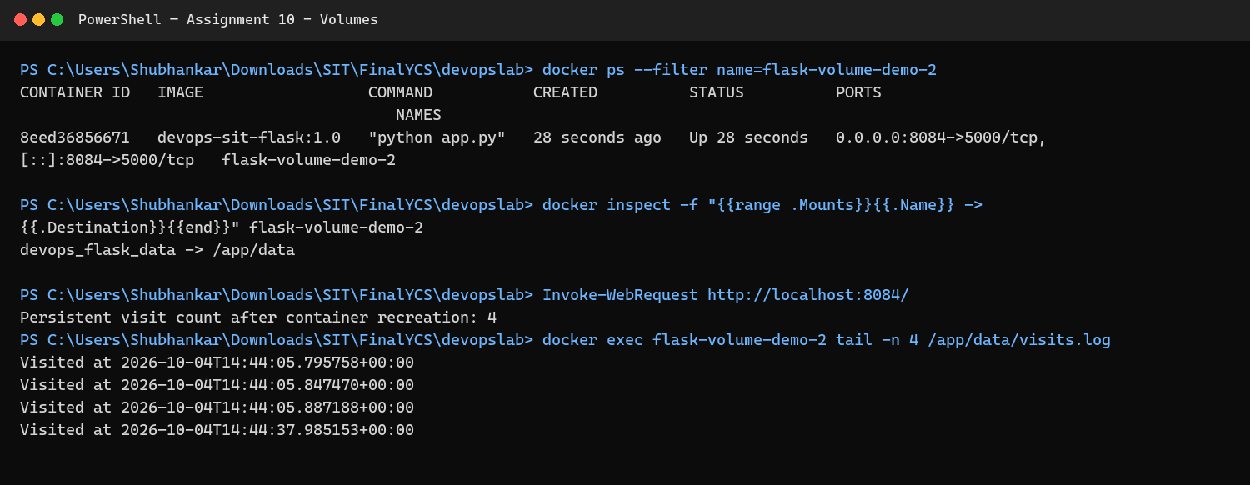  Figure 10.1: Create and test a named volume
Step 2 | Verify the persistent application result  The application workflow demonstrated that state remained available independently of the container.  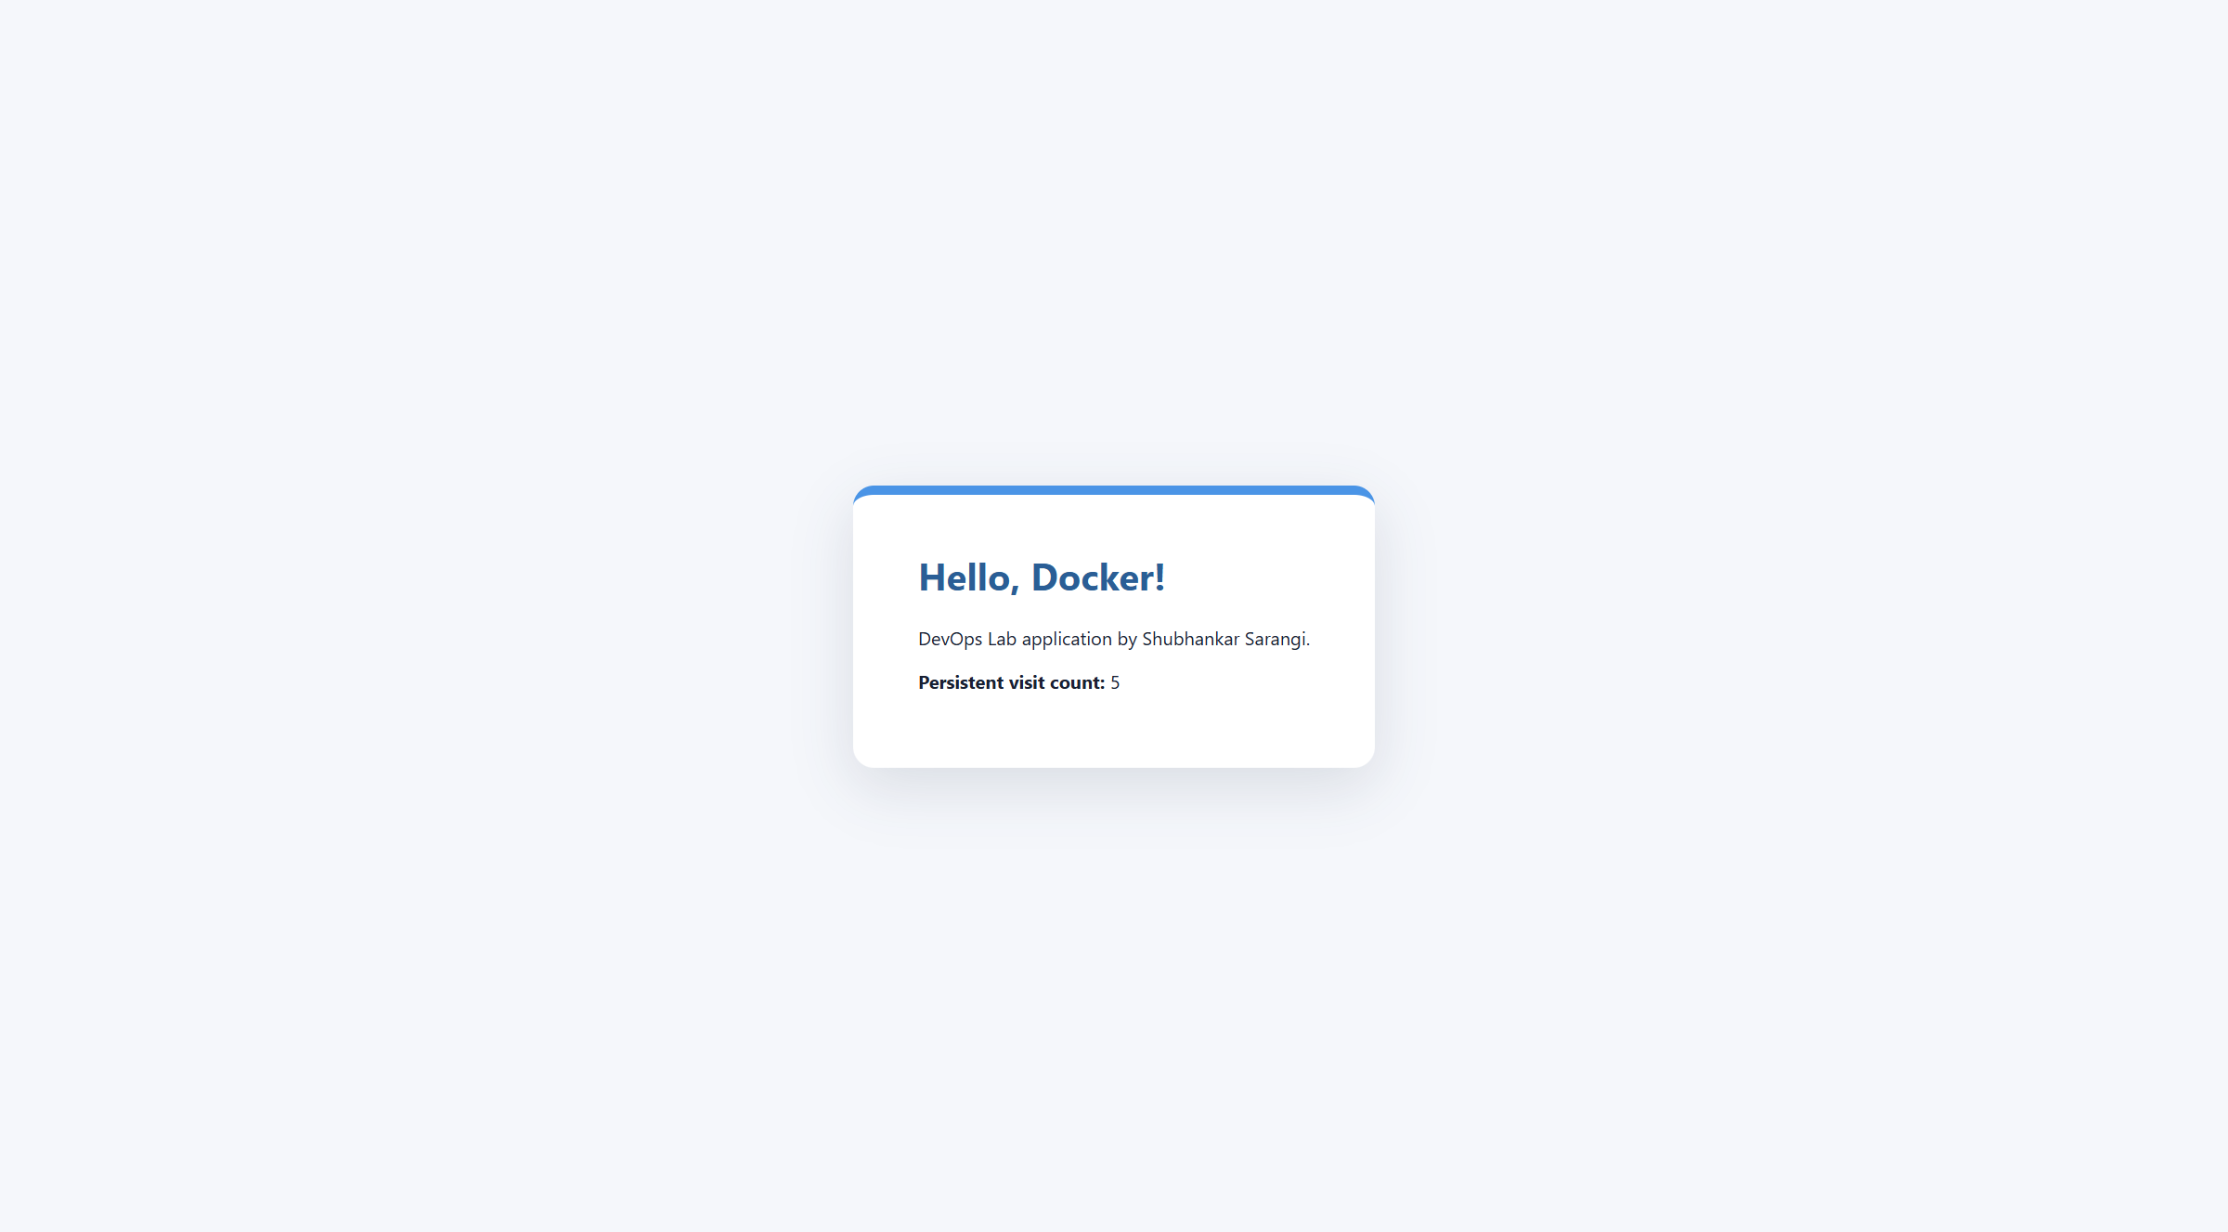  Figure 10.2: Verify the persistent application result
Result: | The assignment workflow completed successfully, and the screenshots above were captured from the student's implementation.
Subject Faculty Name: Prof. Arijit Dutta

SYMBIOSIS INSTITUTE OF TECHNOLOGY, PUNE
Symbiosis International (Deemed University)
(Established under section 3 of the UGC Act, 1956)
Re-accredited by NAAC with 'A' grade (3.58/4) | Awarded Category - I by UGC
Founder: Prof. Dr. S. B. Mujumdar, M. Sc., Ph. D. (Awarded Padma Bhushan and Padma Shri by President of India)
Assignment No. 11
Subject: | DevOps Lab
TCODE: | TE7950
Name of Student | Shubhankar Sarangi
PRN No. | 23070122206
Branch | CSE, Batch (2023-27), L3
Academic Year &  Semester | 2025-26, Sem VII
Date of Performance | 23rd July, 2026
Title of Assignment: | Docker Compose for Multi-Container App
Theory: | Key concepts  • Docker Compose defines a multi-container application in one YAML file.  • Services describe images, builds, ports, environment variables, dependencies, networks, and volumes.  • Compose creates a shared default network so the Flask service can resolve the Redis service by name.  • A named Redis volume preserves data while docker compose up and down control the complete application stack.  Commands / configuration used  • docker compose -f compose-app/compose.yaml up -d --build  • docker compose -f compose-app/compose.yaml ps  • docker compose -f compose-app/compose.yaml logs  • Open http://localhost:8082  • docker compose -f compose-app/compose.yaml down
Implementation: | Workflow and evidence
Step 1 | Build the Compose services  Compose built the Flask service and prepared the Redis dependency.  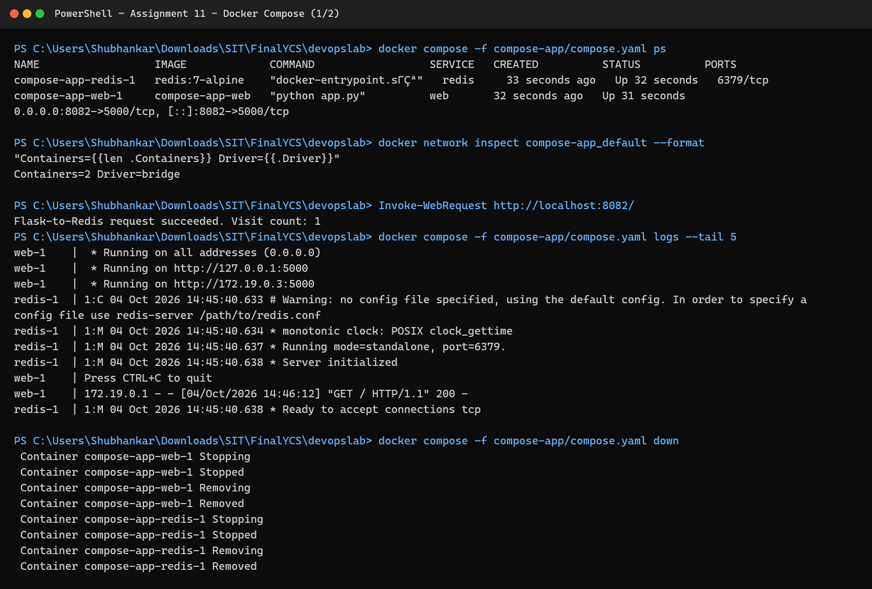  Figure 11.1: Build the Compose services
Step 2 | Start and inspect the service stack  Both services reached the running state on the shared Compose network.  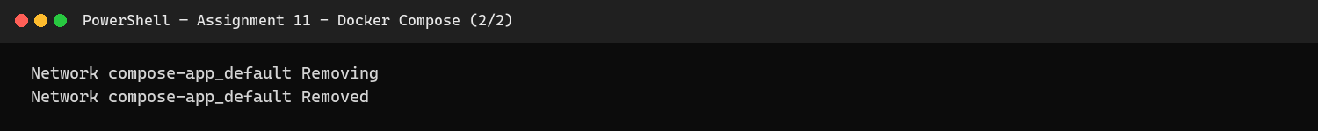  Figure 11.2: Start and inspect the service stack
Step 3 | Verify Flask and Redis integration  The browser response confirms successful communication between the web and Redis containers.  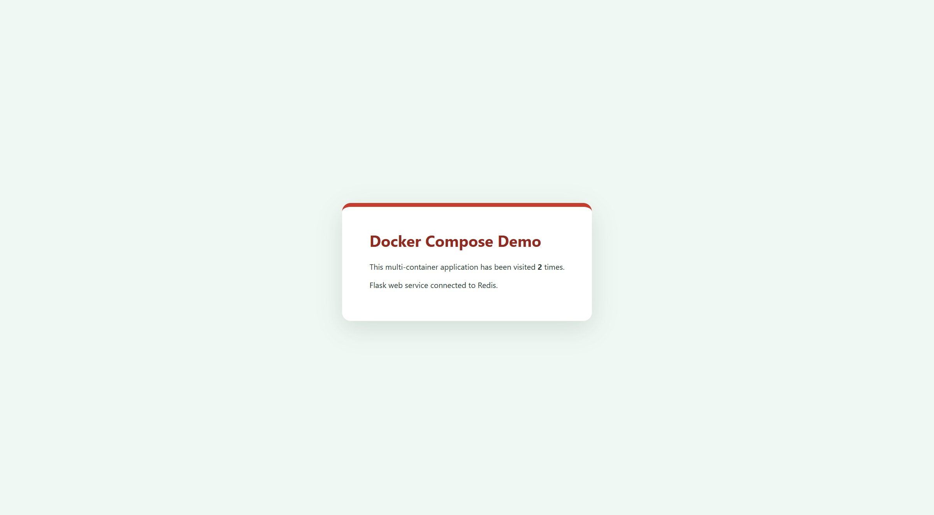  Figure 11.3: Verify Flask and Redis integration
Result: | The assignment workflow completed successfully, and the screenshots above were captured from the student's implementation.
Subject Faculty Name: Prof. Arijit Dutta

SYMBIOSIS INSTITUTE OF TECHNOLOGY, PUNE
Symbiosis International (Deemed University)
(Established under section 3 of the UGC Act, 1956)
Re-accredited by NAAC with 'A' grade (3.58/4) | Awarded Category - I by UGC
Founder: Prof. Dr. S. B. Mujumdar, M. Sc., Ph. D. (Awarded Padma Bhushan and Padma Shri by President of India)
Assignment No. 12
Subject: | DevOps Lab
TCODE: | TE7950
Name of Student | Shubhankar Sarangi
PRN No. | 23070122206
Branch | CSE, Batch (2023-27), L3
Academic Year &  Semester | 2025-26, Sem VII
Date of Performance | 23rd July, 2026
Title of Assignment: | Kubernetes Pod & Deployment
Theory: | Key concepts  • A Pod is Kubernetes' smallest deployable unit and contains one or more tightly coupled containers.  • A Deployment manages a desired number of identical Pod replicas through a ReplicaSet.  • Labels and selectors associate the Deployment with its Pods, while readiness probes control traffic eligibility.  • Declarative manifests make the desired cluster state reviewable, repeatable, and self-healing.  Commands / configuration used  • kind create cluster --name devops-lab  • kind load docker-image devops-sit-flask:1.0 --name devops-lab  • kubectl apply -f kubernetes/deployment.yaml  • kubectl get deployments,pods -o wide  • kubectl describe deployment flask-app-deployment
Implementation: | Workflow and evidence
Step 1 | Create the cluster and apply the Deployment  The application image was loaded into Kind and the Deployment manifest was applied.  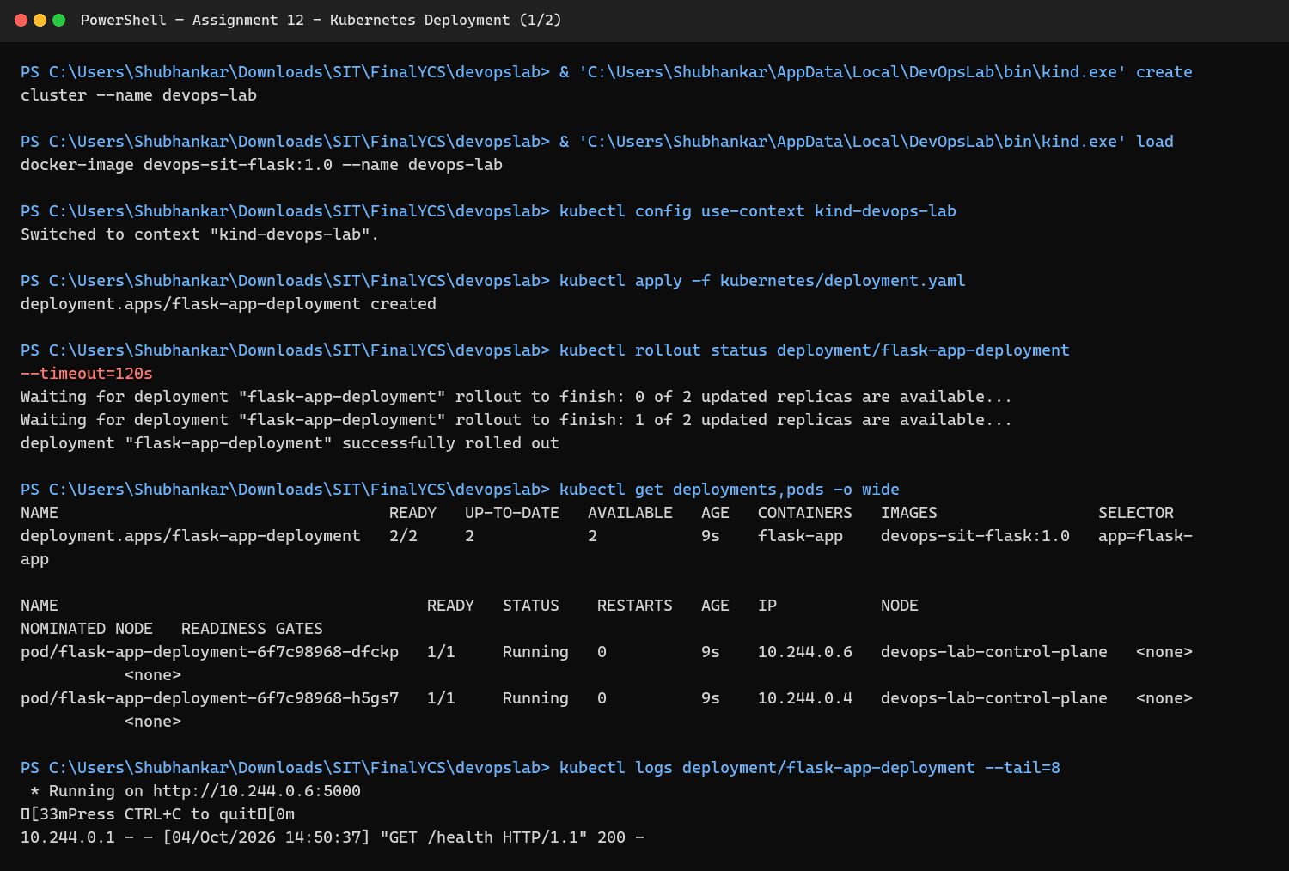  Figure 12.1: Create the cluster and apply the Deployment
Step 2 | Verify Deployment replicas and Pods  Kubernetes reported the desired replicas as available and ready.  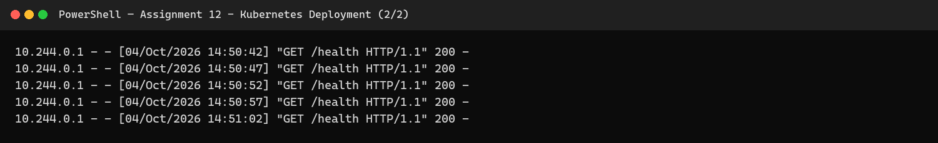  Figure 12.2: Verify Deployment replicas and Pods
Result: | The assignment workflow completed successfully, and the screenshots above were captured from the student's implementation.
Subject Faculty Name: Prof. Arijit Dutta

SYMBIOSIS INSTITUTE OF TECHNOLOGY, PUNE
Symbiosis International (Deemed University)
(Established under section 3 of the UGC Act, 1956)
Re-accredited by NAAC with 'A' grade (3.58/4) | Awarded Category - I by UGC
Founder: Prof. Dr. S. B. Mujumdar, M. Sc., Ph. D. (Awarded Padma Bhushan and Padma Shri by President of India)
Assignment No. 13
Subject: | DevOps Lab
TCODE: | TE7950
Name of Student | Shubhankar Sarangi
PRN No. | 23070122206
Branch | CSE, Batch (2023-27), L3
Academic Year &  Semester | 2025-26, Sem VII
Date of Performance | 23rd July, 2026
Title of Assignment: | Kubernetes Service & Networking
Theory: | Key concepts  • Pods are replaceable, so a Kubernetes Service provides a stable virtual IP and DNS name.  • A Service selector discovers matching Pods and load-balances traffic across their endpoints.  • port is the Service-facing port, targetPort is the container port, and NodePort exposes a fixed port on each node.  • Endpoints and an HTTP request verify that the Service routes traffic to ready application Pods.  Commands / configuration used  • kubectl apply -f kubernetes/service.yaml  • kubectl get service flask-app-service  • kubectl get endpoints flask-app-service  • kubectl port-forward service/flask-app-service 8084:80  • Open http://localhost:8084
Implementation: | Workflow and evidence
Step 1 | Create and inspect the Kubernetes Service  The NodePort Service selected the Flask Pods and exposed port 80 to the cluster.  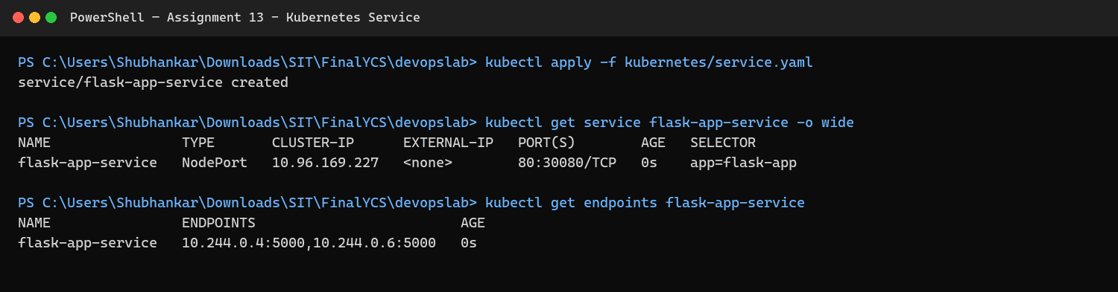  Figure 13.1: Create and inspect the Kubernetes Service
Step 2 | Verify Service routing  A browser request routed through the Service and reached the deployed Flask application.  Figure 13.2: Verify Service routing
Result: | The assignment workflow completed successfully, and the screenshots above were captured from the student's implementation.
Subject Faculty Name: Prof. Arijit Dutta

SYMBIOSIS INSTITUTE OF TECHNOLOGY, PUNE
Symbiosis International (Deemed University)
(Established under section 3 of the UGC Act, 1956)
Re-accredited by NAAC with 'A' grade (3.58/4) | Awarded Category - I by UGC
Founder: Prof. Dr. S. B. Mujumdar, M. Sc., Ph. D. (Awarded Padma Bhushan and Padma Shri by President of India)
Assignment No. 14
Subject: | DevOps Lab
TCODE: | TE7950
Name of Student | Shubhankar Sarangi
PRN No. | 23070122206
Branch | CSE, Batch (2023-27), L3
Academic Year &  Semester | 2025-26, Sem VII
Date of Performance | 23rd July, 2026
Title of Assignment: | CI/CD: Jenkins Pipeline Building a Docker Image
Theory: | Key concepts  • CI/CD combines automated integration checks with repeatable delivery steps.  • The Jenkins controller image includes the Docker CLI and uses the host Docker socket to invoke the Docker engine.  • The version-controlled Jenkinsfile checks out the repository, builds a uniquely tagged image, and validates it.  • A successful pipeline links a source revision, Jenkins build number, and produced Docker image for traceability.  Commands / configuration used  • checkout scm  • docker build -t devops-sit-flask:${BUILD_NUMBER} my-flask-app  • docker image inspect devops-sit-flask:${BUILD_NUMBER}  • Run the Jenkins pipeline from the repository Jenkinsfile
Implementation: | Workflow and evidence
Step 1 | Build the Docker image from Jenkins  The pipeline checked out the repository and executed the Docker image build.  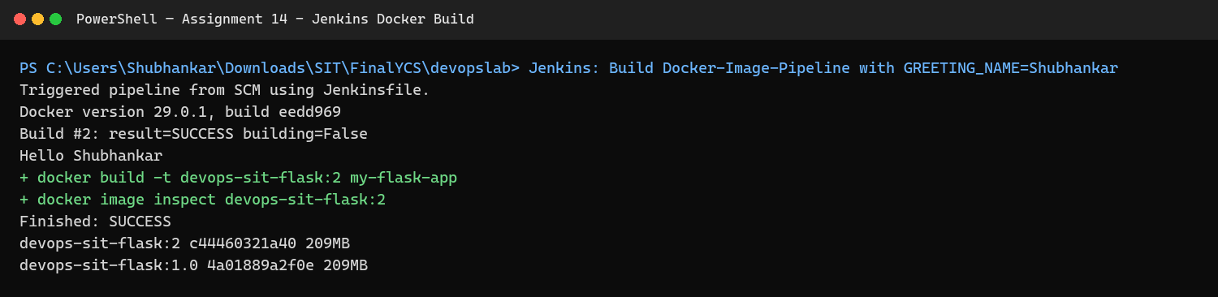  Figure 14.1: Build the Docker image from Jenkins
Step 2 | Verify CI/CD stages  The Jenkins stage view confirms successful checkout, image build, and validation.  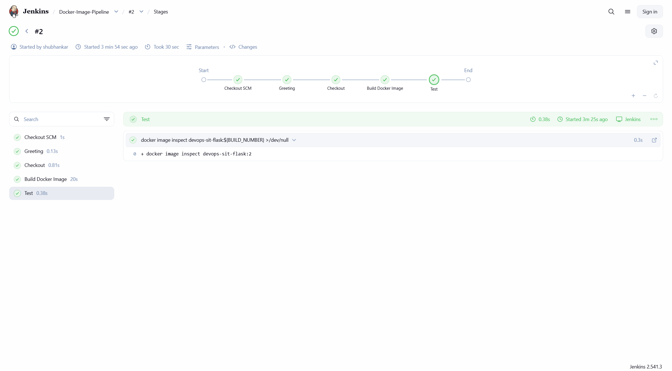  Figure 14.2: Verify CI/CD stages
Result: | The assignment workflow completed successfully, and the screenshots above were captured from the student's implementation.
Subject Faculty Name: Prof. Arijit Dutta

SYMBIOSIS INSTITUTE OF TECHNOLOGY, PUNE
Symbiosis International (Deemed University)
(Established under section 3 of the UGC Act, 1956)
Re-accredited by NAAC with 'A' grade (3.58/4) | Awarded Category - I by UGC
Founder: Prof. Dr. S. B. Mujumdar, M. Sc., Ph. D. (Awarded Padma Bhushan and Padma Shri by President of India)
Assignment No. 15
Subject: | DevOps Lab
TCODE: | TE7950
Name of Student | Shubhankar Sarangi
PRN No. | 23070122206
Branch | CSE, Batch (2023-27), L3
Academic Year &  Semester | 2025-26, Sem VII
Date of Performance | 23rd July, 2026
Title of Assignment: | Basic Infrastructure as Code with Terraform
Theory: | Key concepts  • Infrastructure as Code describes resources in version-controlled configuration instead of manual procedures.  • Terraform uses providers to manage resources and maintains state to compare configuration with real infrastructure.  • terraform init installs providers, plan previews changes, apply converges the state, and destroy removes managed resources.  • An update plan demonstrates idempotent change management, while the final destroy proves lifecycle cleanup.  Commands / configuration used  • terraform -chdir=terraform init  • terraform -chdir=terraform fmt -check  • terraform -chdir=terraform validate  • terraform -chdir=terraform plan  • terraform -chdir=terraform apply -auto-approve  • terraform -chdir=terraform destroy -auto-approve
Implementation: | Workflow and evidence
Step 1 | Initialize and validate Terraform  Terraform installed the required local provider and validated the configuration.  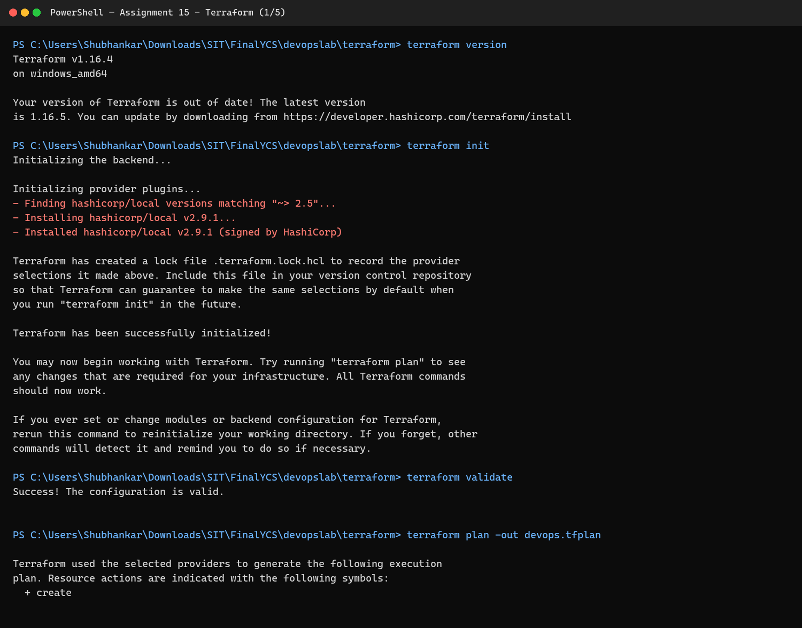  Figure 15.1: Initialize and validate Terraform
Step 2 | Review the execution plan  The plan described the local file resource before any change was applied.  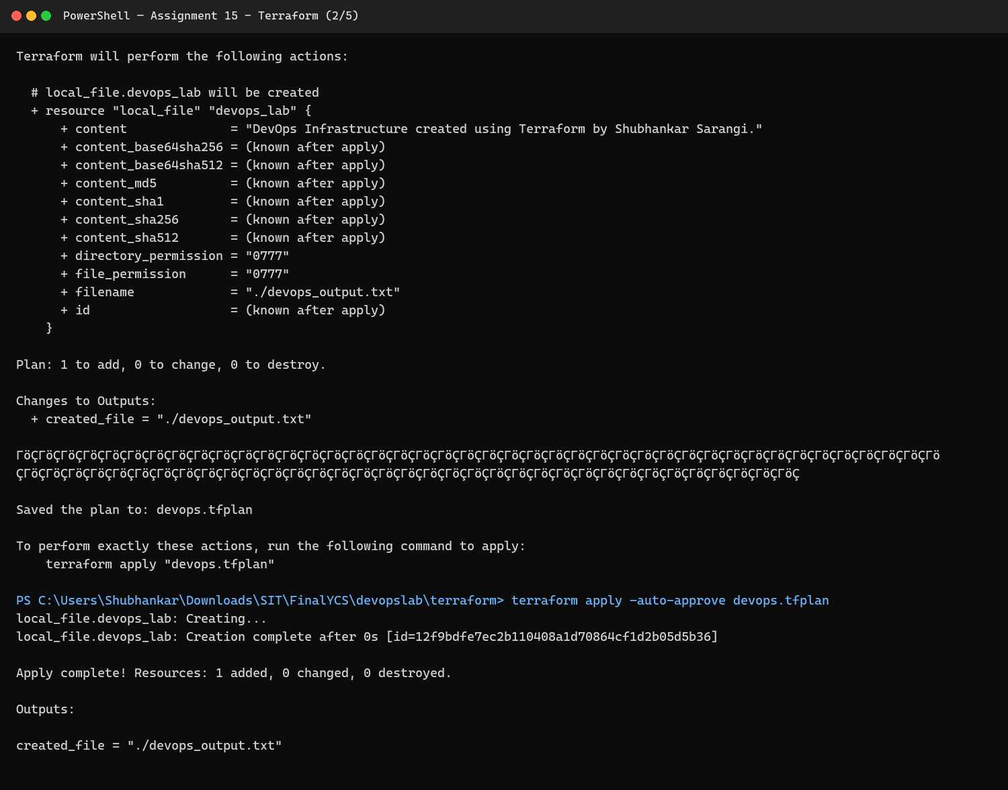  Figure 15.2: Review the execution plan
Step 3 | Apply and verify the resource  Terraform created the managed file and displayed the configured output.  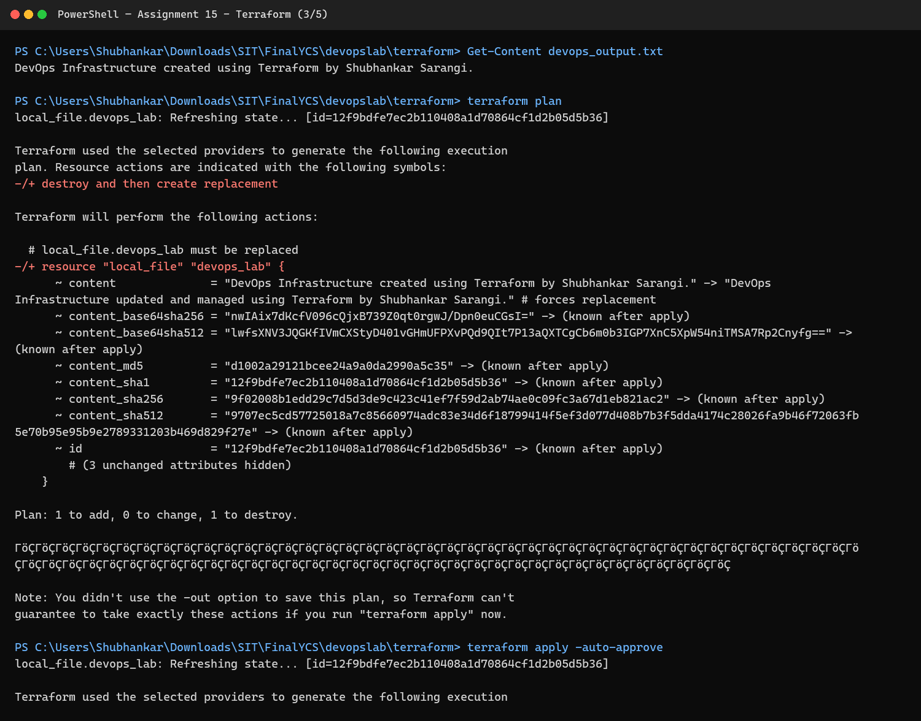  Figure 15.3: Apply and verify the resource
Step 4 | Update the managed infrastructure  A changed configuration produced an update plan and was applied through Terraform.  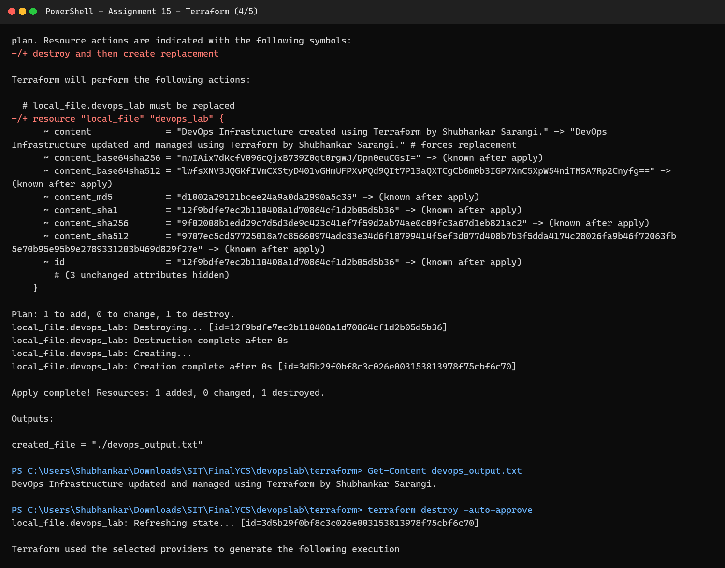  Figure 15.4: Update the managed infrastructure
Step 5 | Destroy and verify cleanup  Terraform removed the managed resource and the final filesystem check confirmed its deletion.  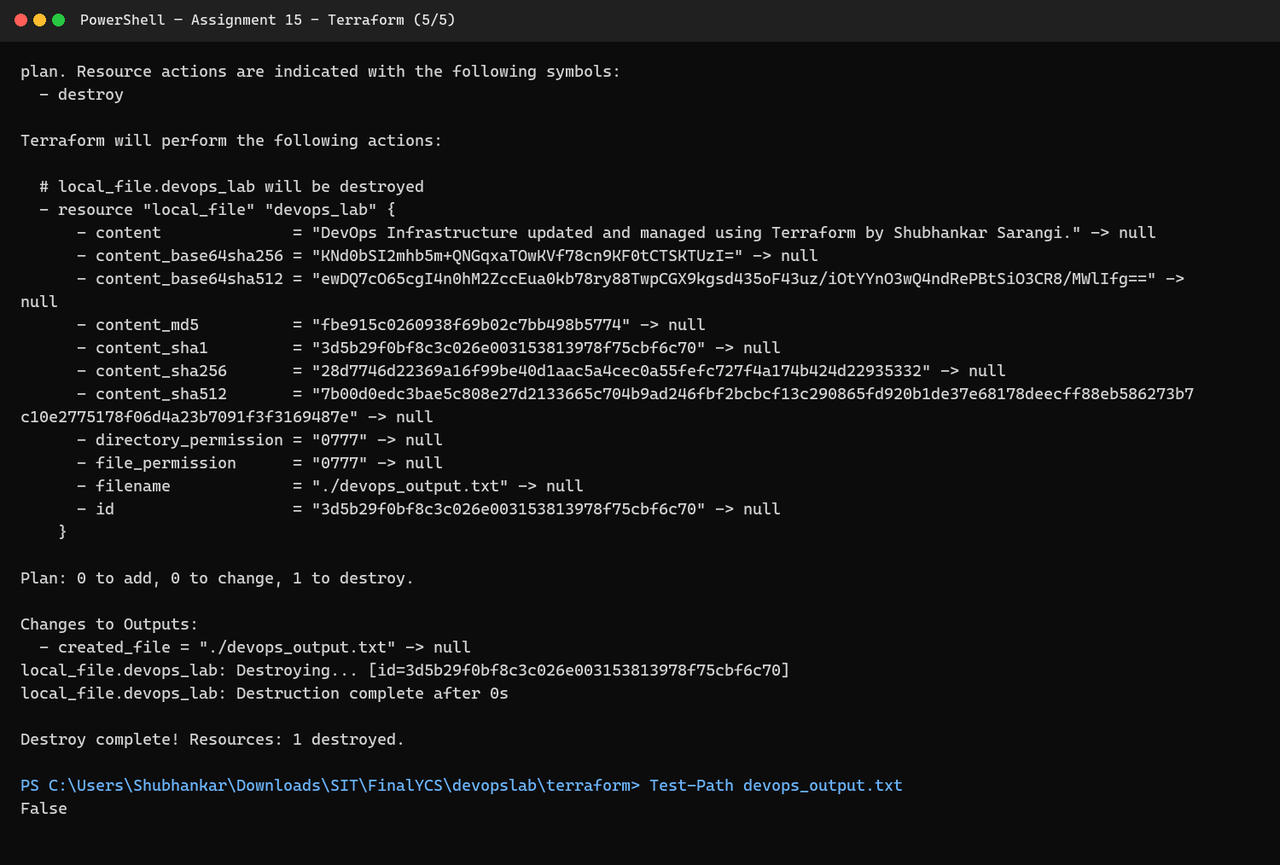  Figure 15.5: Destroy and verify cleanup
Result: | The assignment workflow completed successfully, and the screenshots above were captured from the student's implementation.
Subject Faculty Name: Prof. Arijit Dutta

